**Designing Applications and Architecture in AWS - Course-end Project**

**Author Name: Ieng Lao**

**Email:** [**ilao2014@yahoo.com**](mailto:ilao2014@yahoo.com)

**Project Objectives:**

To set up and monitoring a WordPress instance for your organization is to establish a reliable and secure online presence that supports your business or organizational goals.

**Problem Statement:**

You are given a project. You should be able to configure a WordPress instance using AWS CloudFormation and monitor the instance

**Real-World Scenario:**

Your organization publishes blogs and provides documentation services for other businesses and technologies. You have been asked to:

● Set up a live WordPress instance to publish blogs

● Set up a WordPress instance that can be used for development and testing purposes so that any work done on this instance will not impact the live blog

● Configure the WordPress instance for development and testing purposes, which will be available only during the business hours (9 AM–6 PM

**Task (Activities)**

1. Create a CloudFormation stack

2. Create an AMI of the WordPress instance

3. Configure Auto Scaling to launch a new WordPress instance

4. Configure the new WordPress instance to shut down automatically

**Prerequisites Setup**

**Step 1: Create EC2 Key Pair (5 minutes)**

**Why**: You need this to SSH into your instances if needed.

1. **Open AWS Console**: Go to <https://console.aws.amazon.com>
2. **Sign in** with your AWS account credentials
3. In the **search bar** at the top, type EC2
4. Click **EC2** from the results
5. In the **left sidebar**, look for "Network & Security" section
6. Click **Key Pairs**
7. Click the orange **Create key pair** button (top right)
8. Fill in:
   * **Name**: wordpress-project-key
   * **Key pair type**: Select RSA
   * **Private key file format**:
     + Choose .pem if you use Mac/Linux
     + Choose .ppk if you use Windows with PuTTY
9. Click **Create key pair**
10. **IMPORTANT**: The file will download automatically - save it in a secure location!

**Create key pair screenshots**

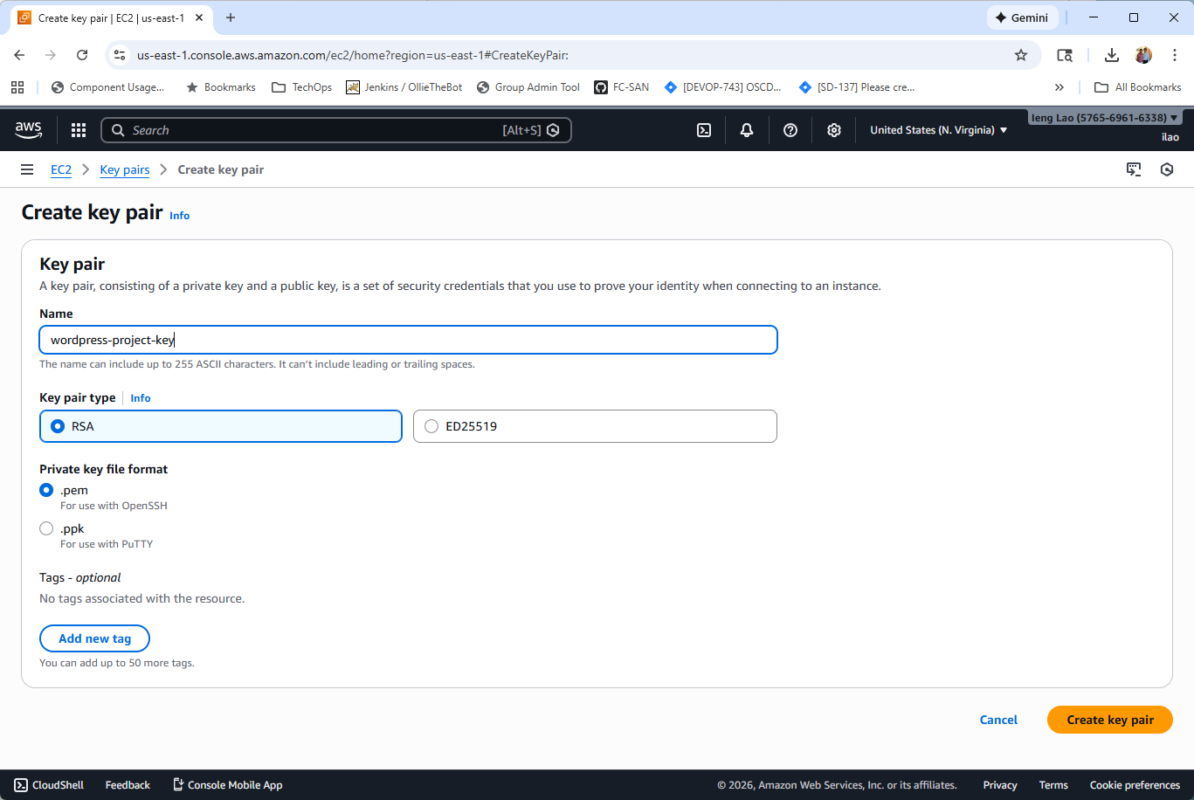

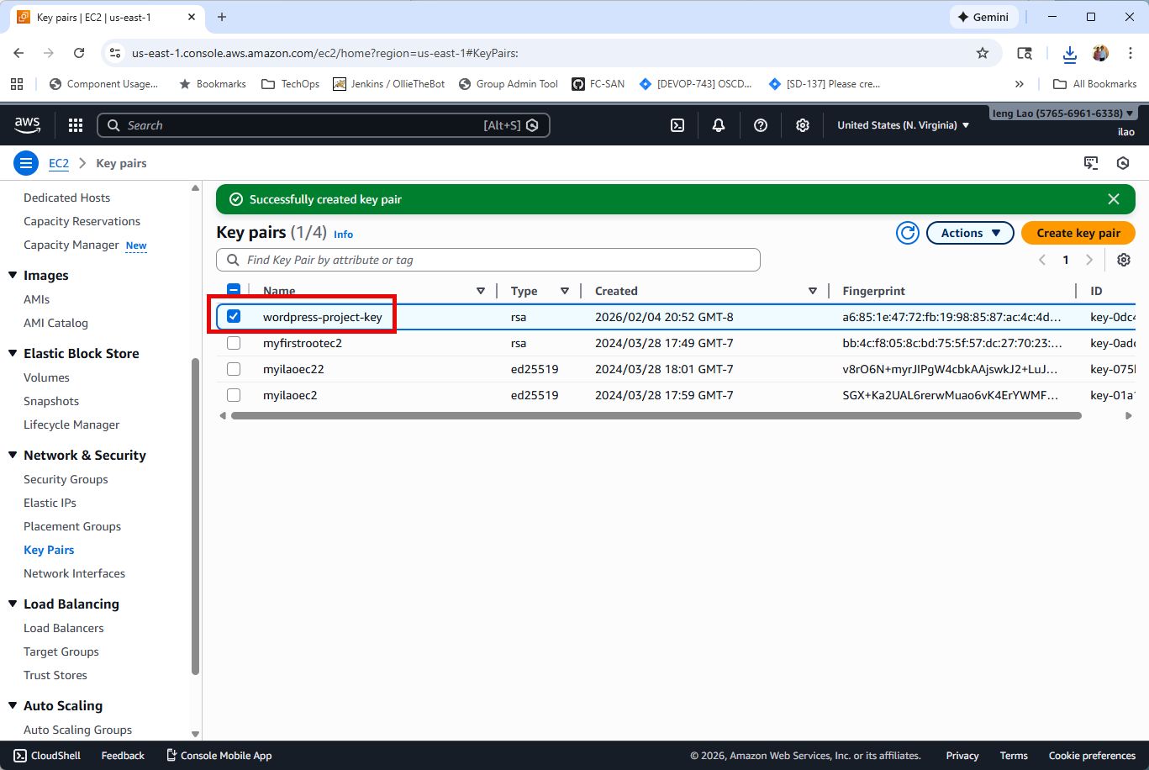

**Task 1: Create CloudFormation Stack for Production WordPress**

Step 1: Prepare CloudFormation Template

1 - Open a text editor on your computer (Notepad, Vi, Others.)

2 - Copy the following CloudFormation template:

See the attachment or filename “CloudFormation_WordPress.yaml”

3 -Save the file as “wordpress-production.yaml” on your computer.

Step 2: Create CloudFormation Stack (took ~10 minutes)

1 - **Go back to AWS Console**

2 - In the **search bar**, type CloudFormation

3 - click **CloudFormation**

4 - click the orange **Create stack** button

5 - select **With new resources (standard), …**

6 – select **Upload a template file, select** CloudFormation_WordPress.yaml, provide Stack name, Key pair name, InstanceType: t2.micro, add new tags Project:WordPress, Environment:Production.

7 - Check the box: **"I acknowledge that AWS CloudFormation might create IAM resources"** 19. Click **Submit (orange button)**

8 – Below are the screenshots of executed steps.

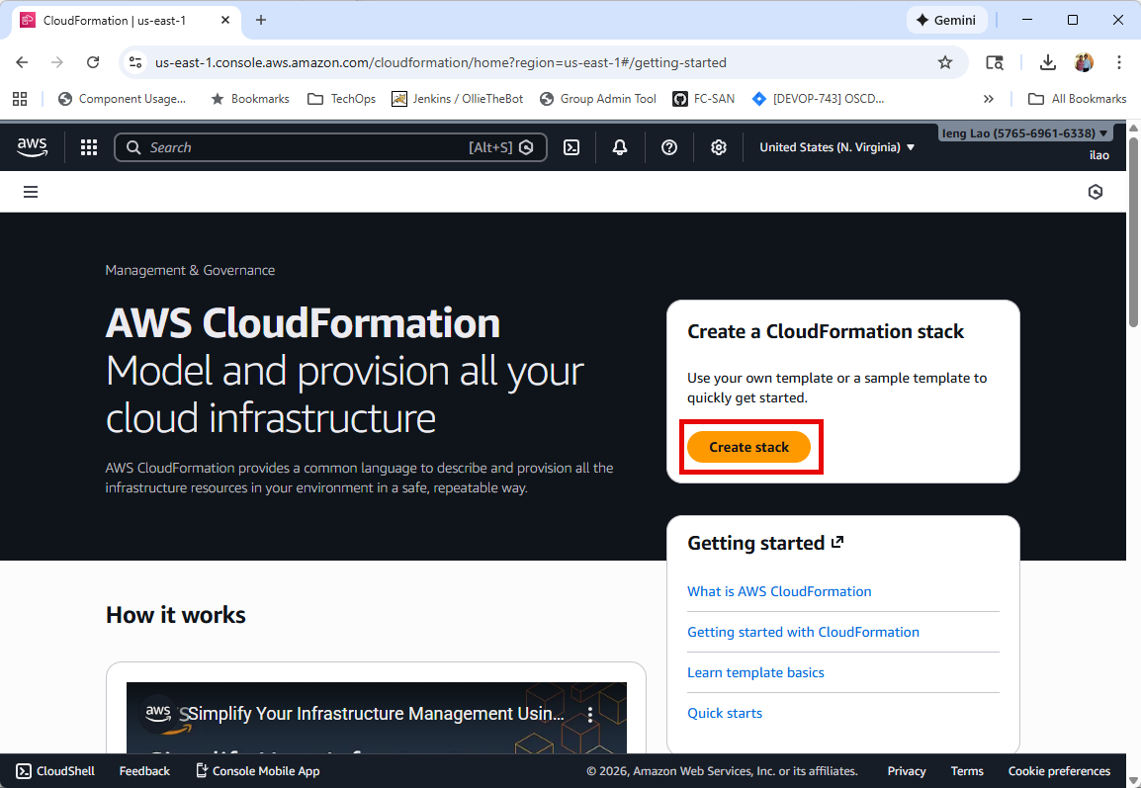

Click on **Create stack** button.

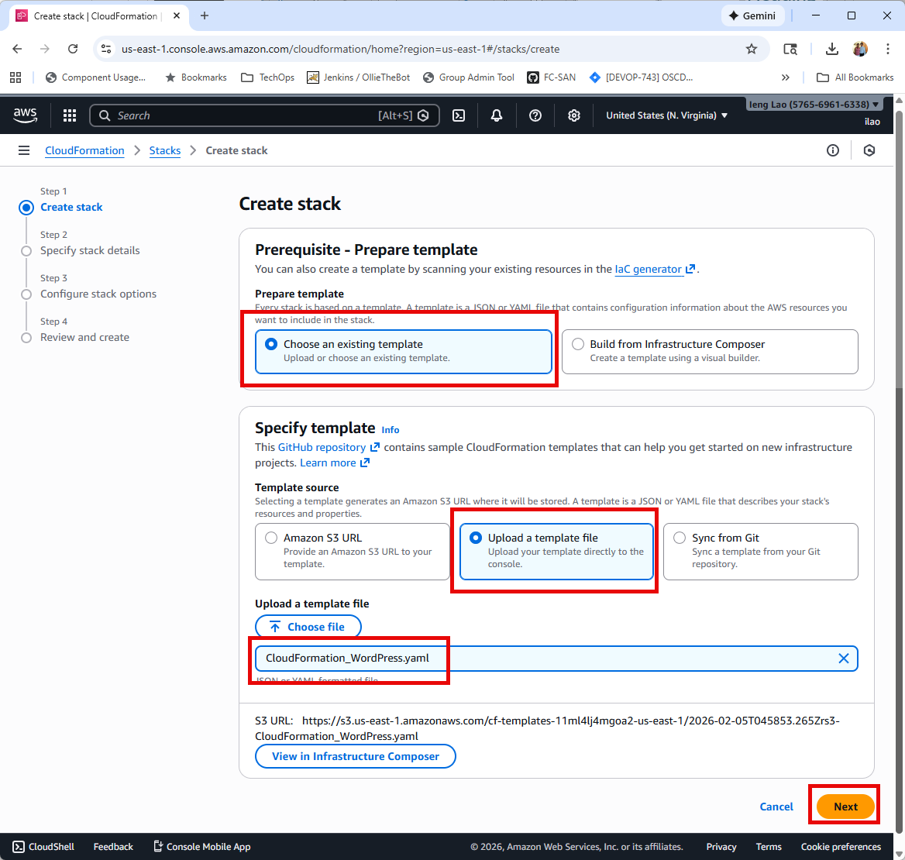

Click on **Next** button.

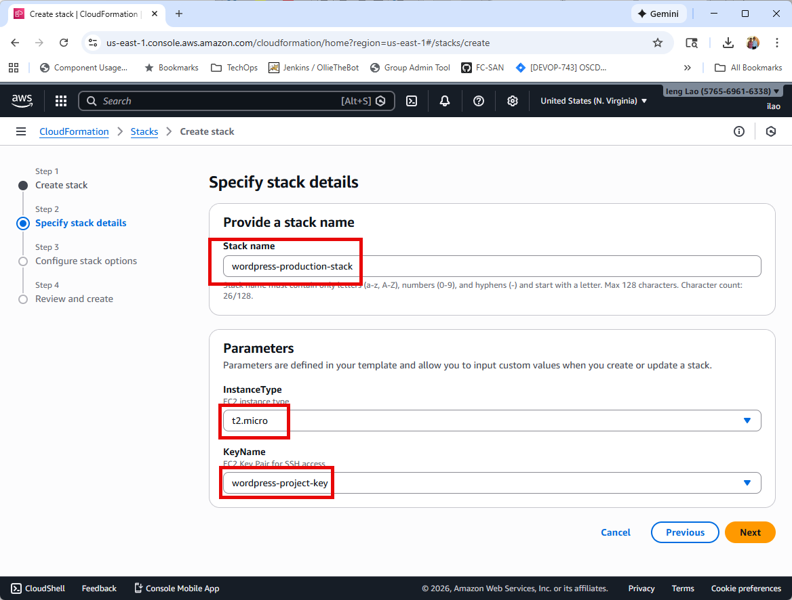

Click on **Next** button.

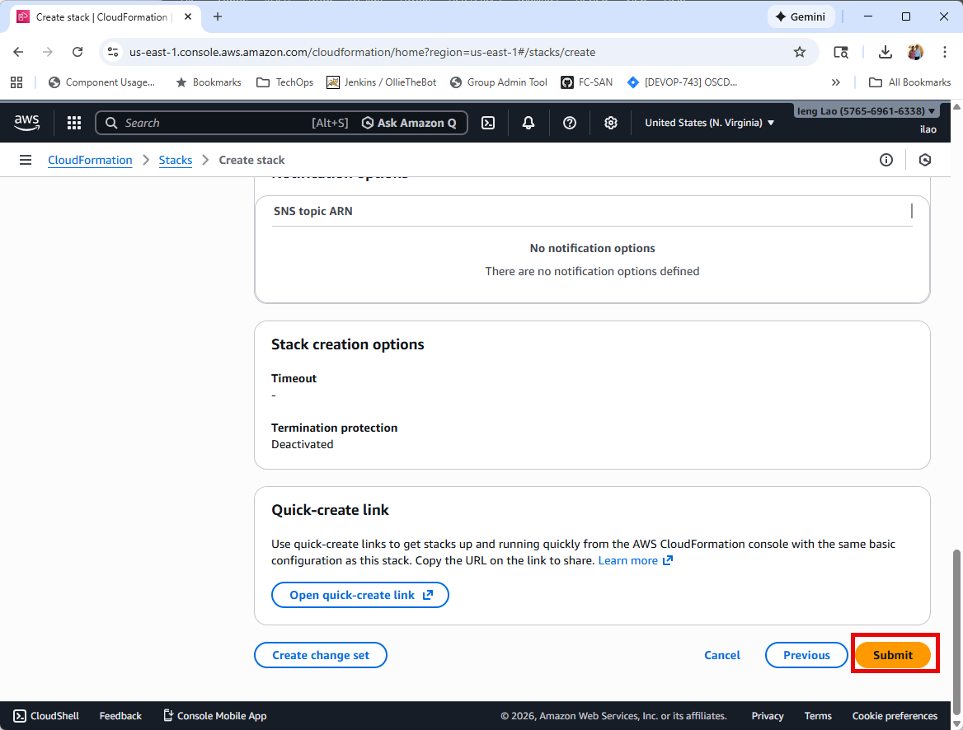

Click on **Submit** button.

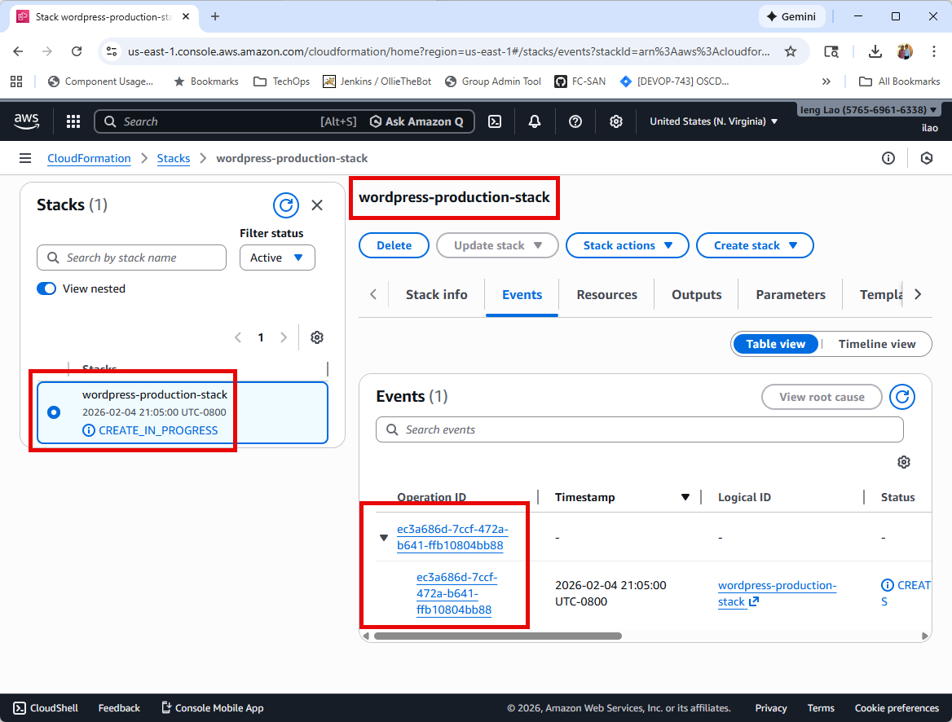

*Status screenshot*

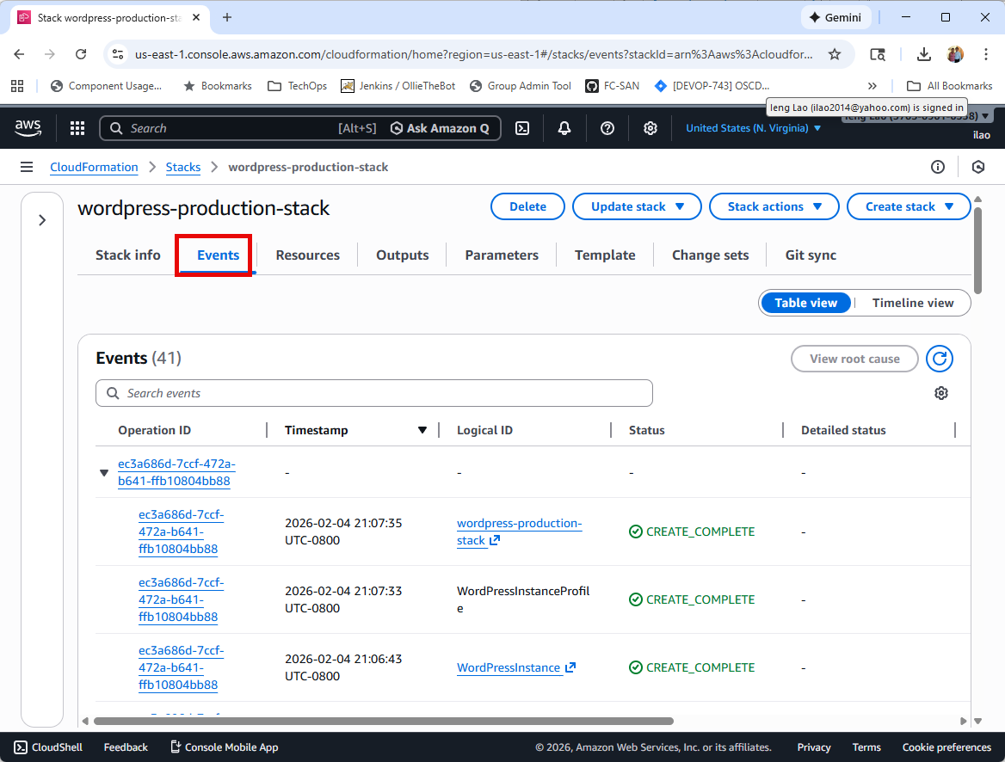

*Status screenshot*

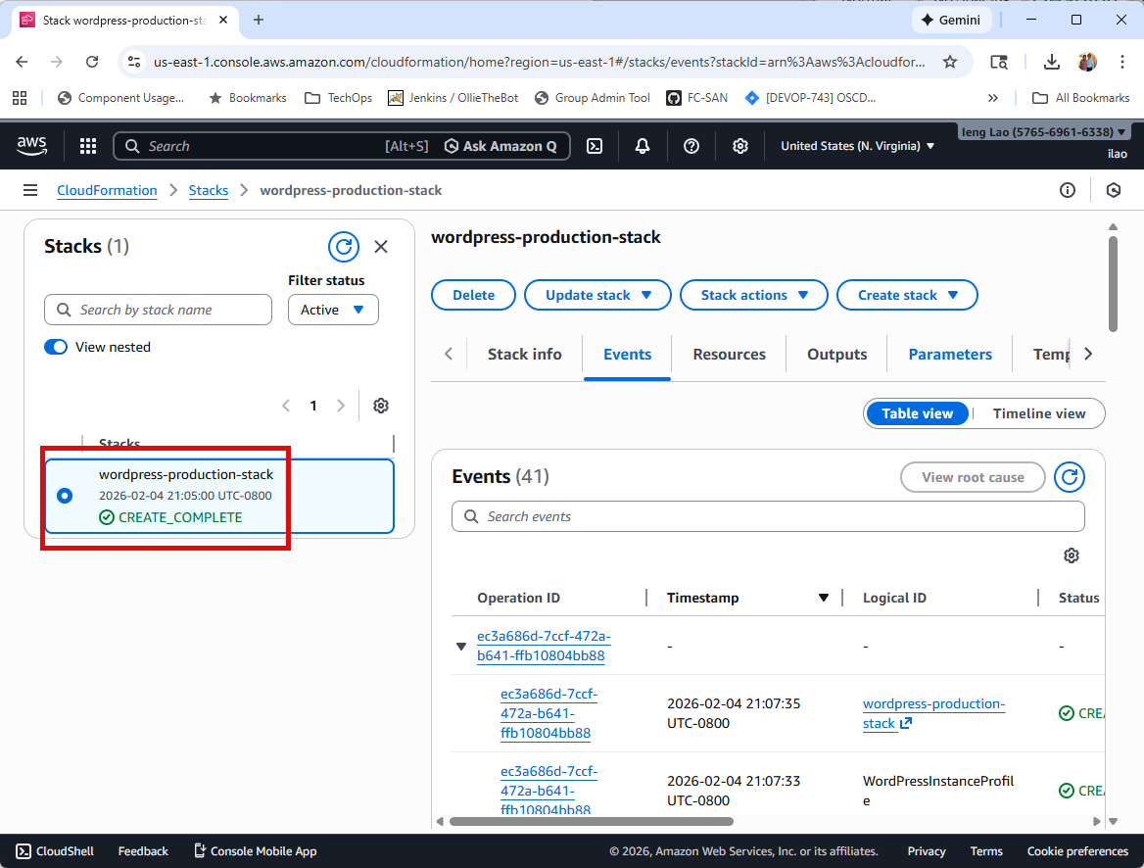

*Status screenshot – 5 minutes to complete*

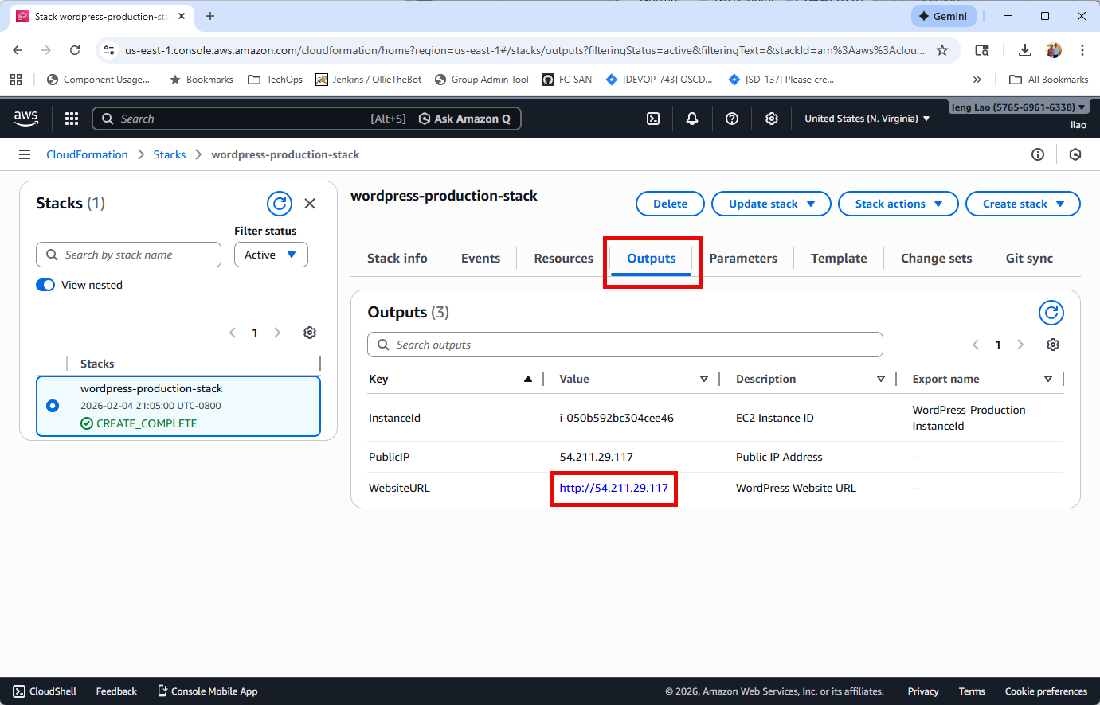

*Status screenshot – Output Information*

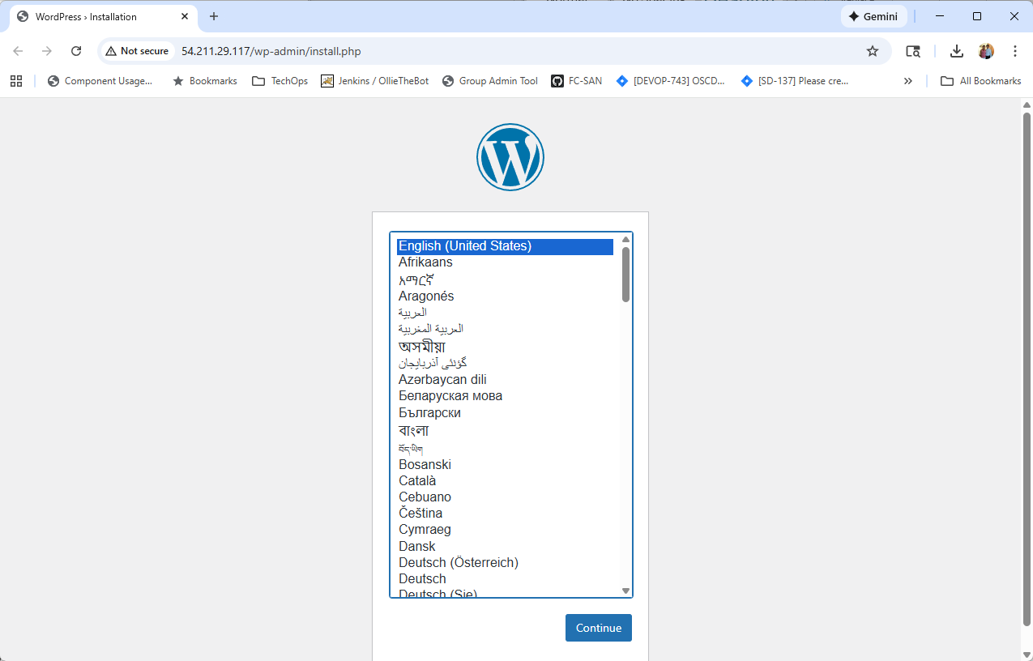

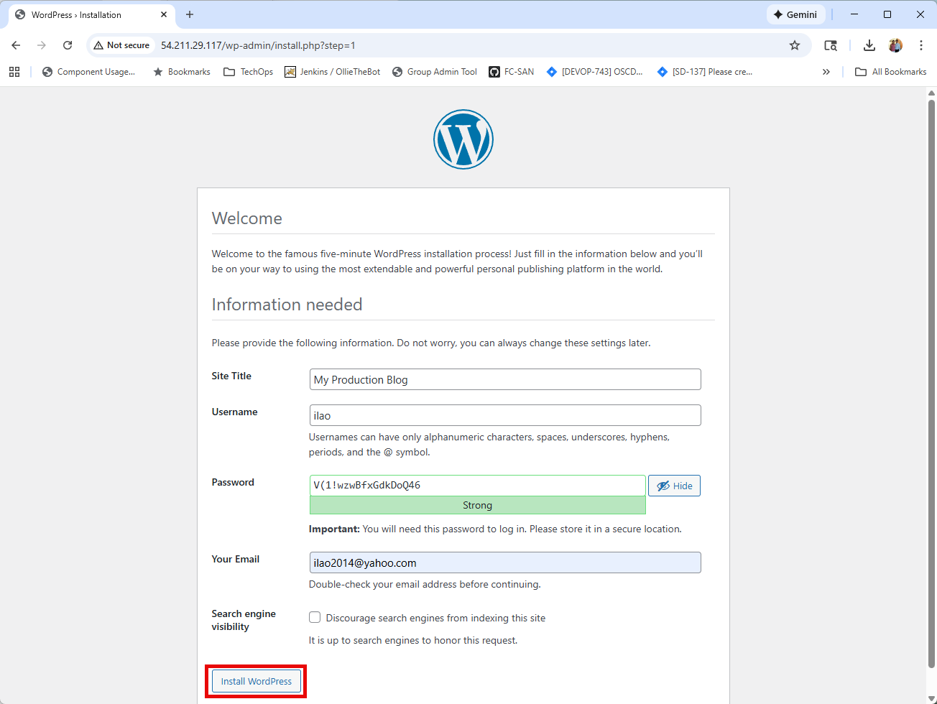

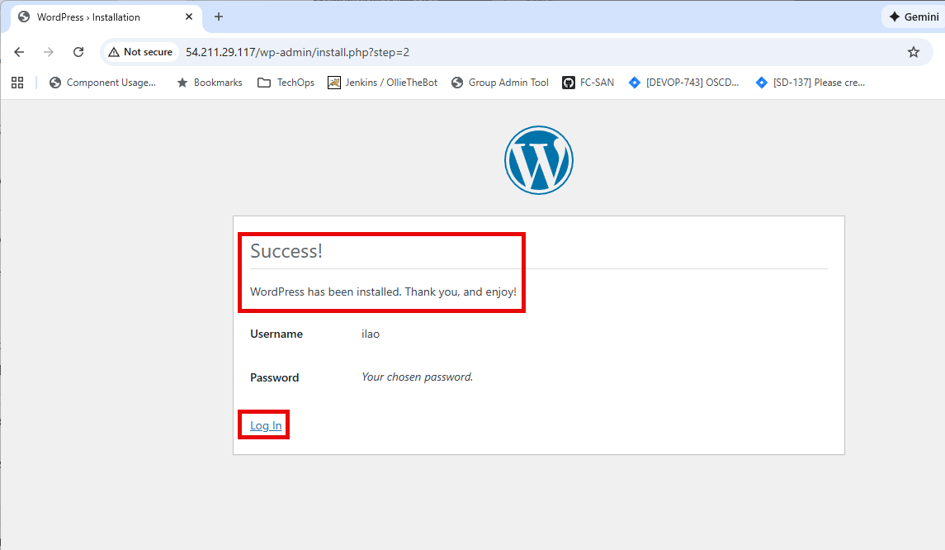

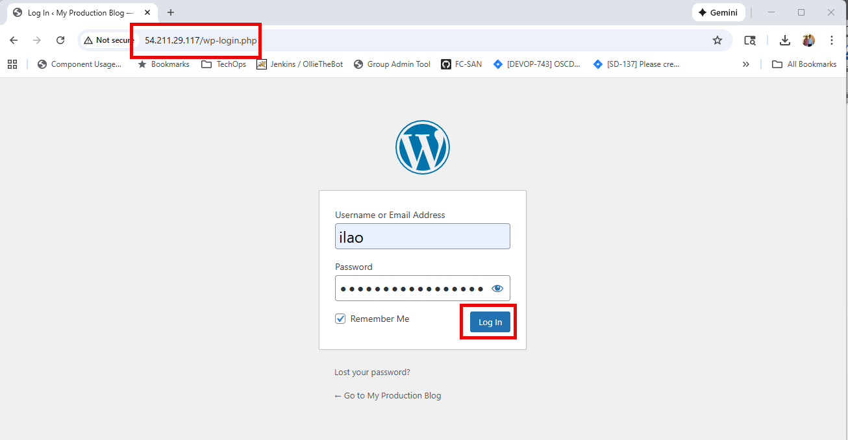

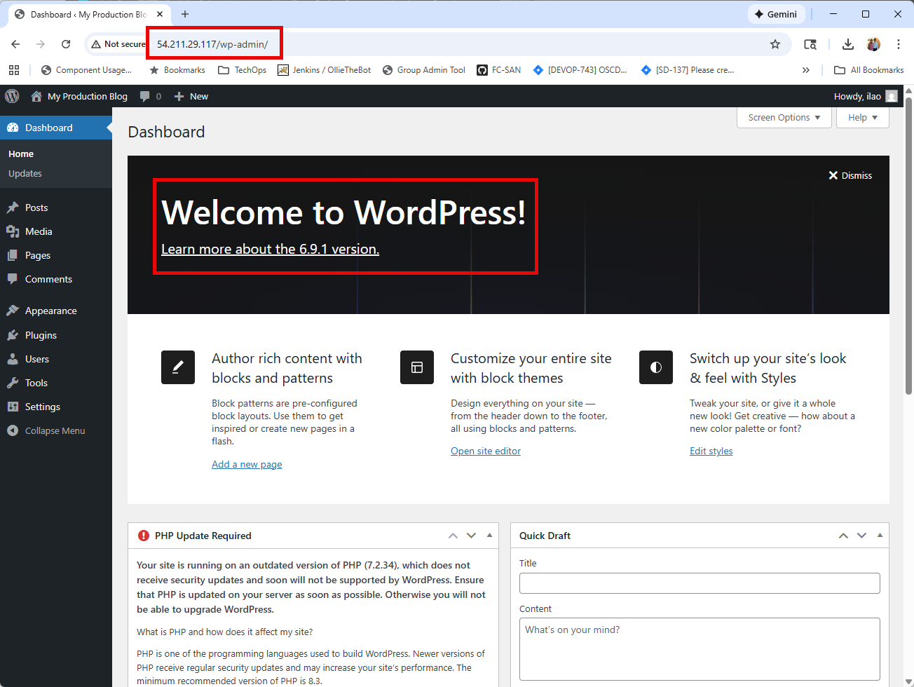

Task 2: Create AMI of WordPress Instance

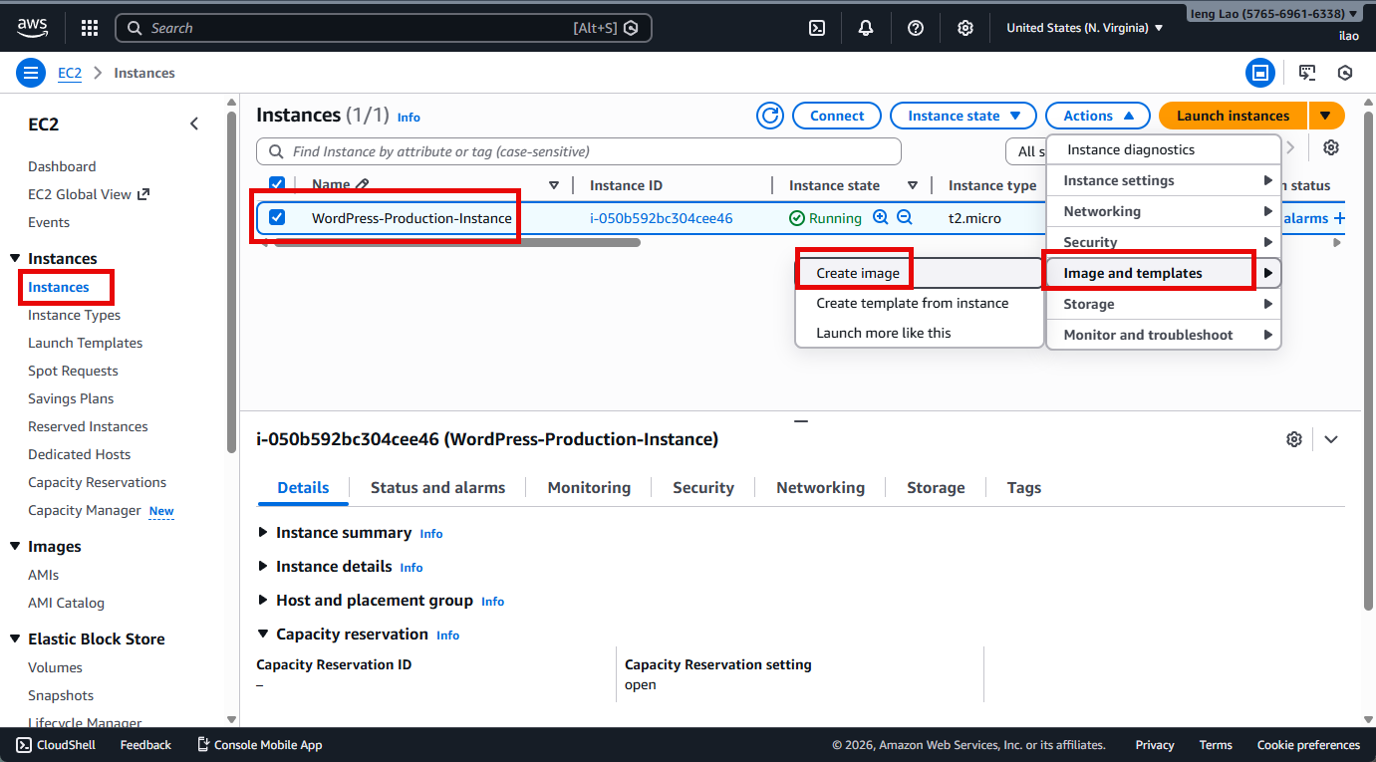

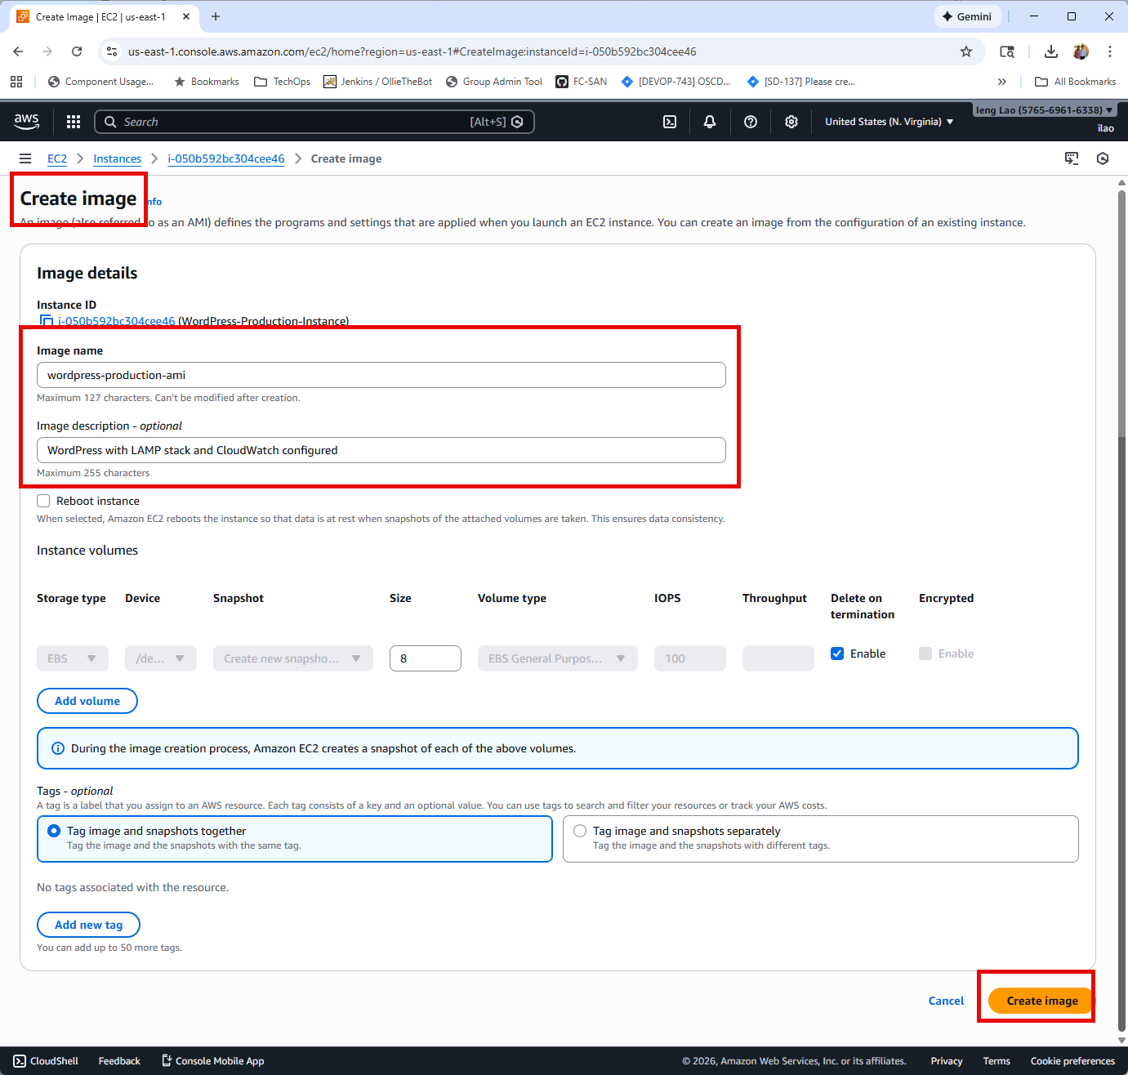

Wait 3 – 5 minutes for status to change from **Pending to Available**.

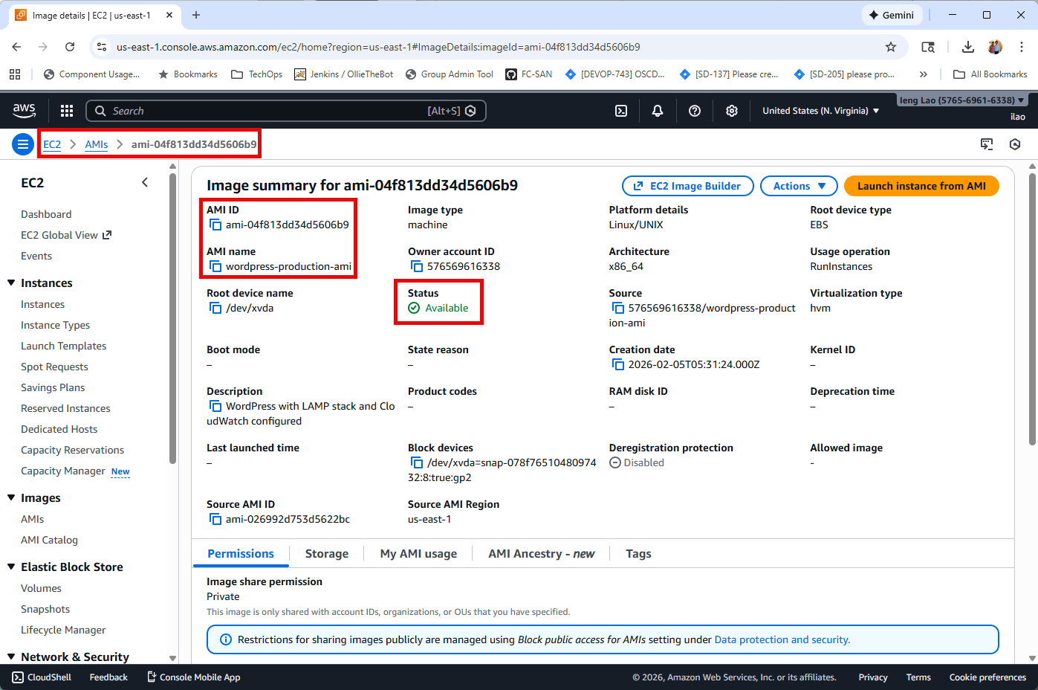

**Task 3: Configure Auto Scaling for Development Instance**

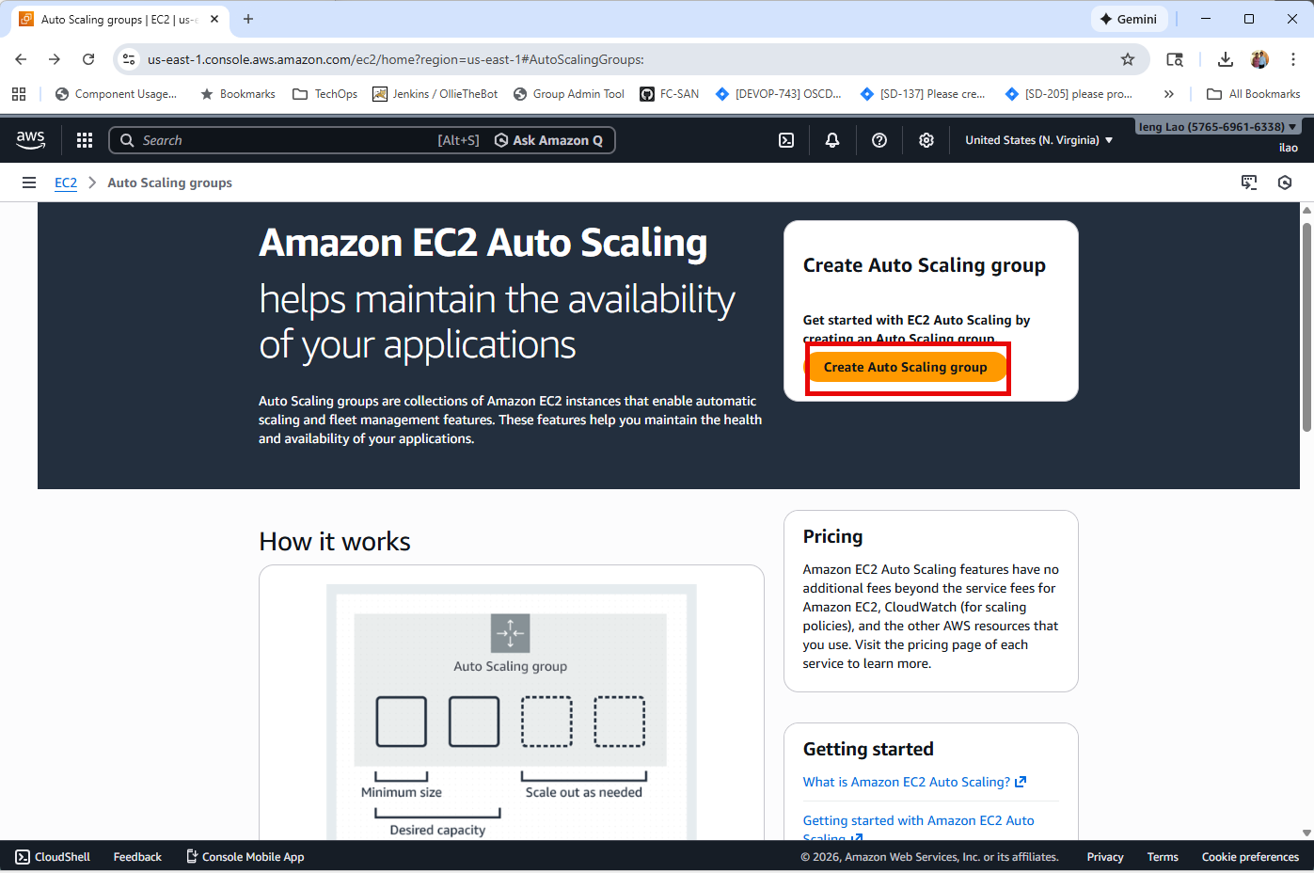

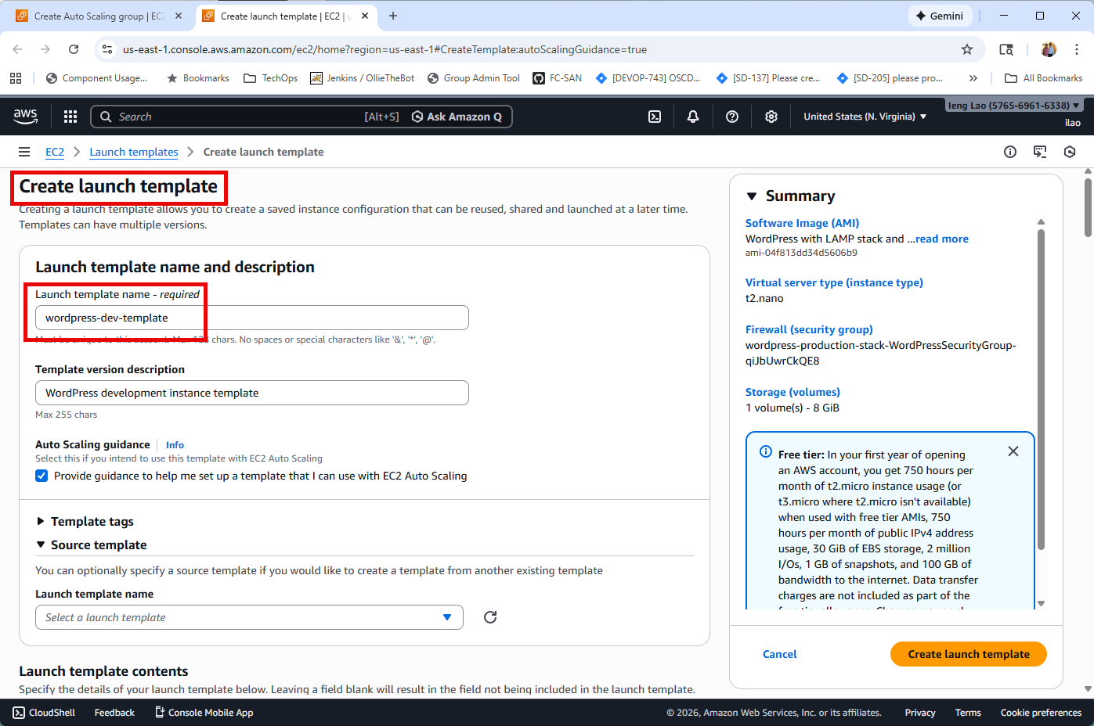

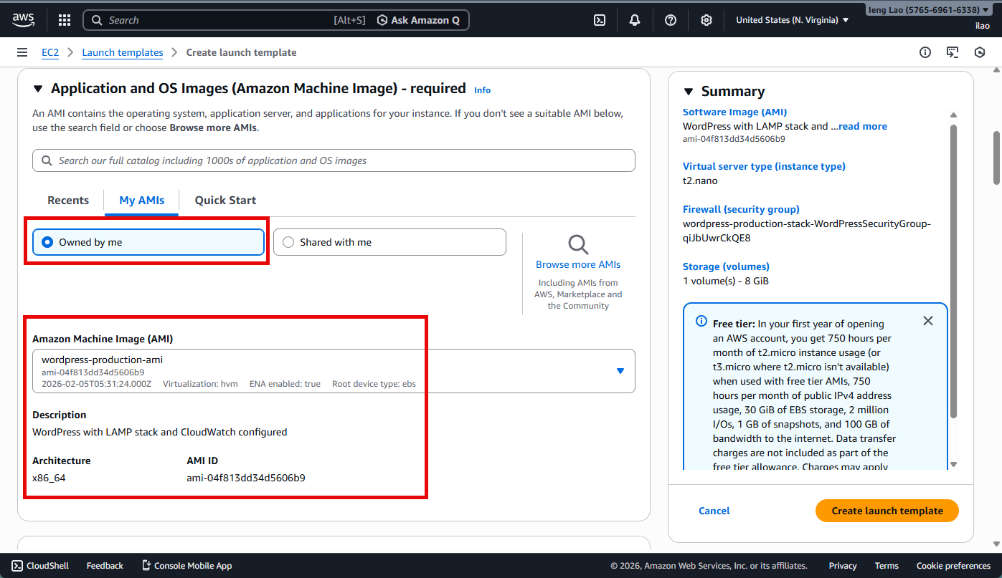

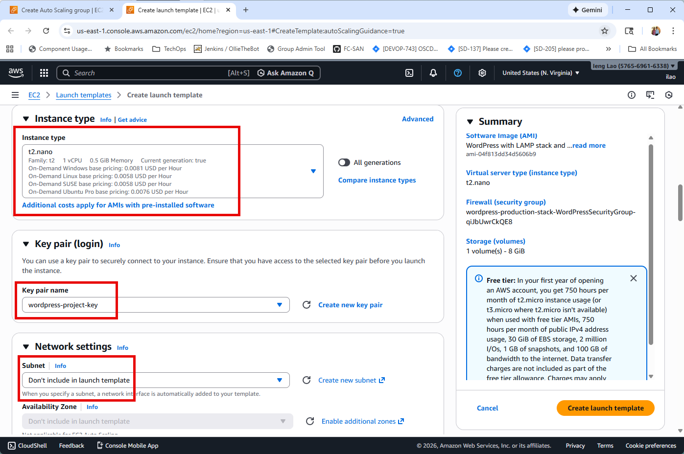

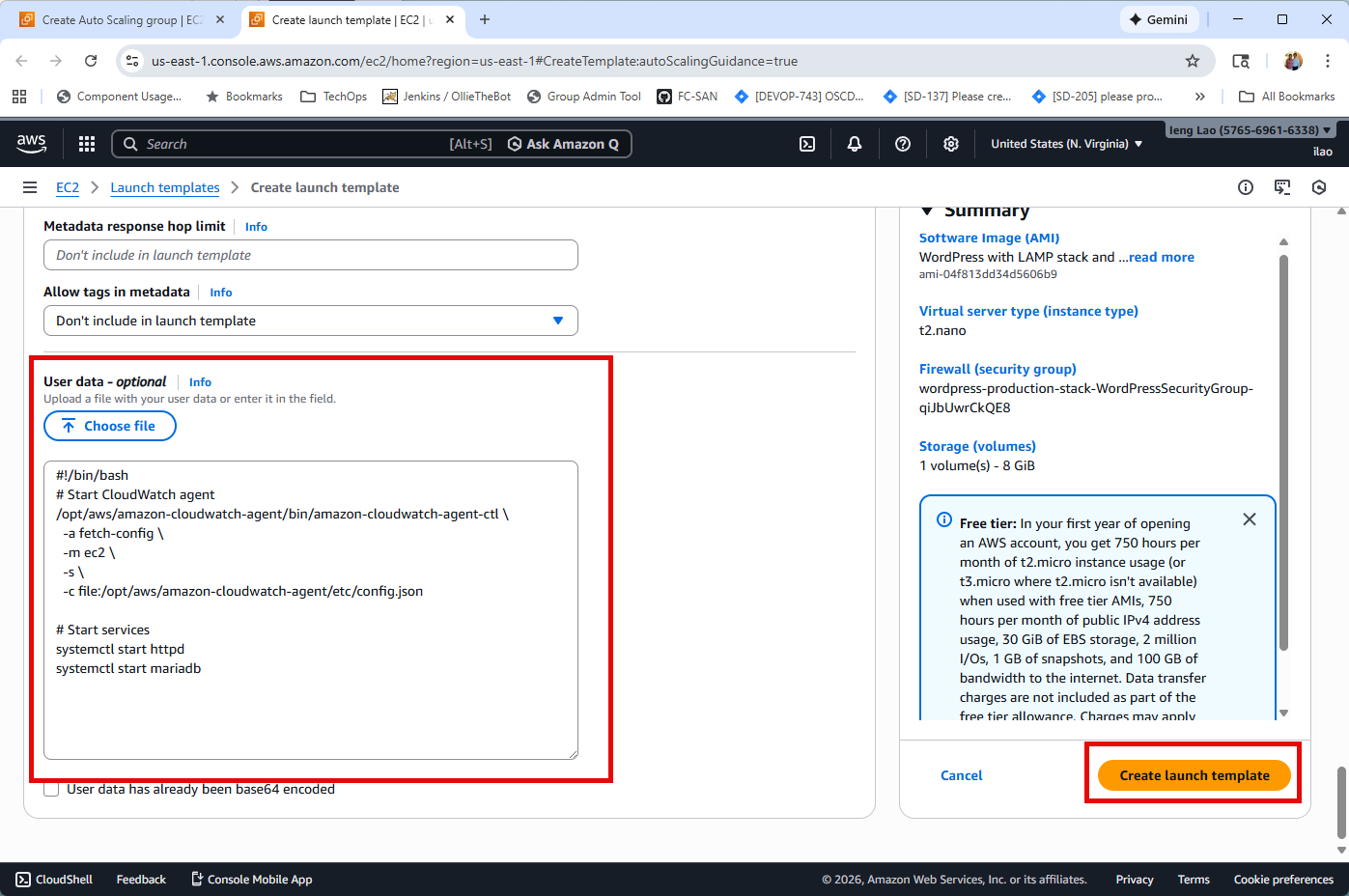

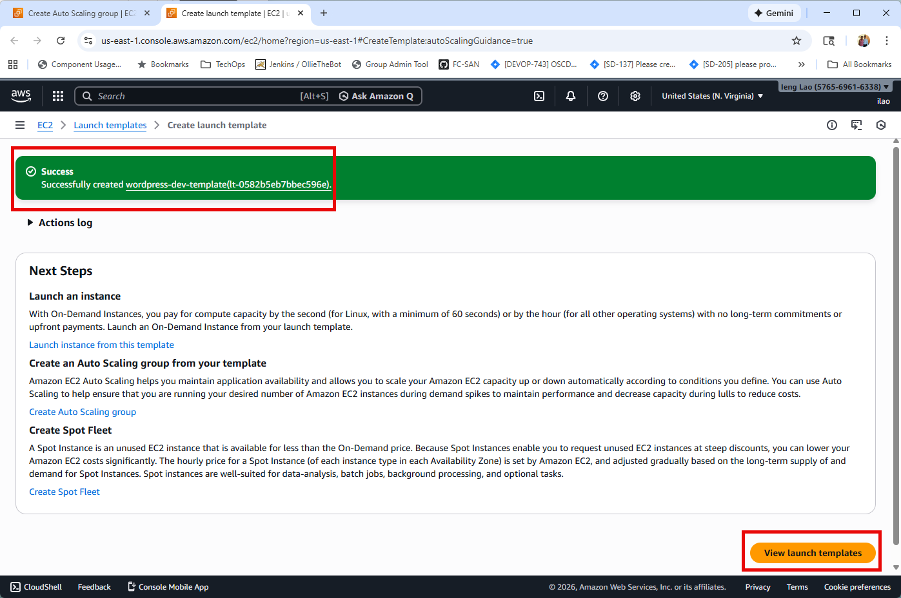

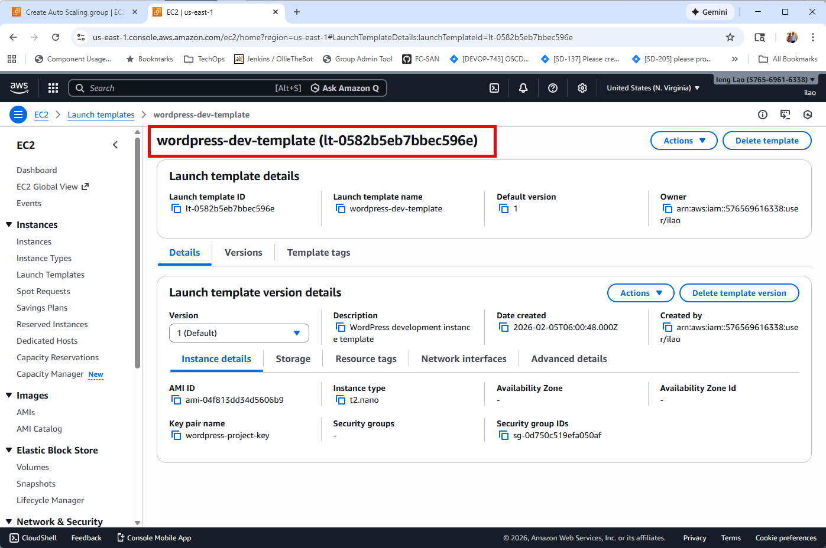

**Task 3.1: Create Auto Scaling Group**

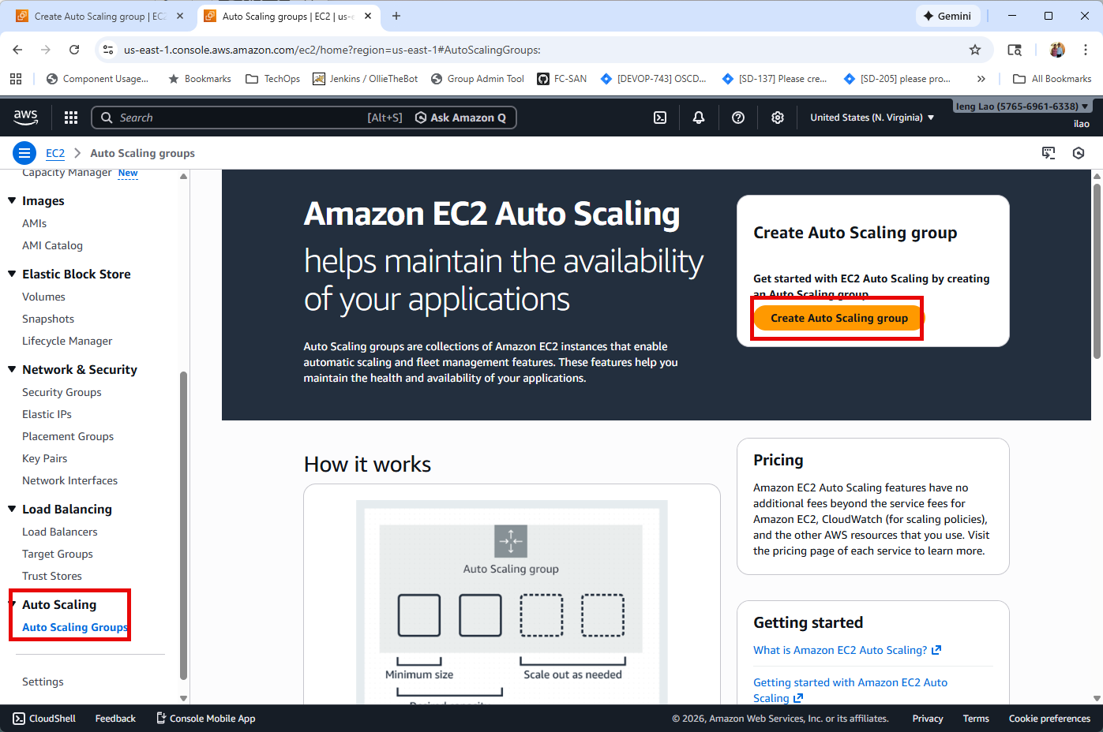

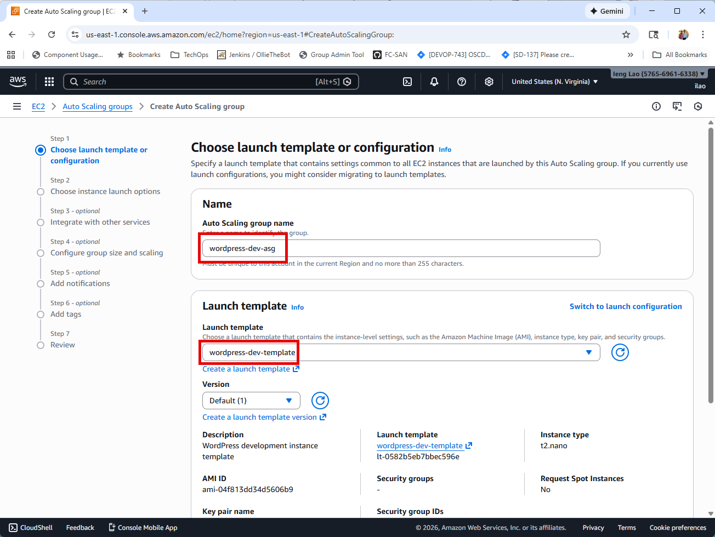

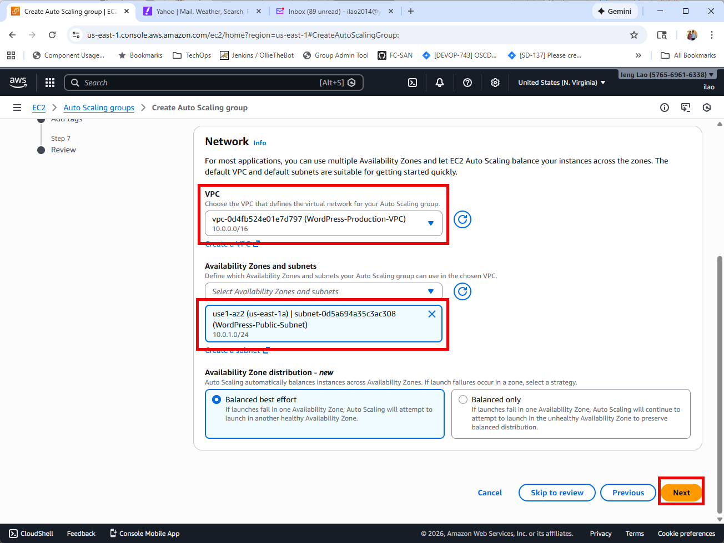

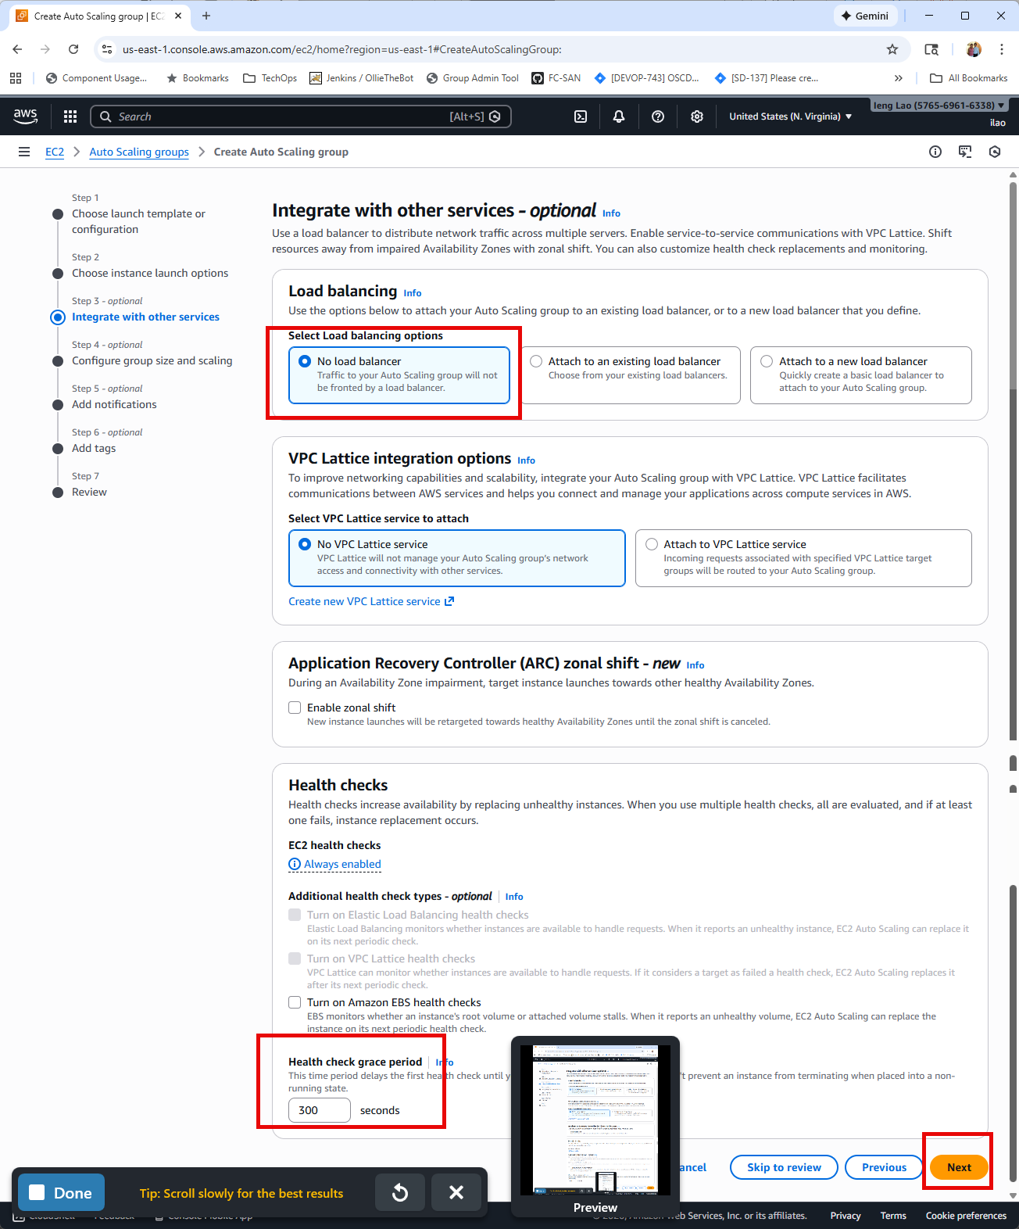

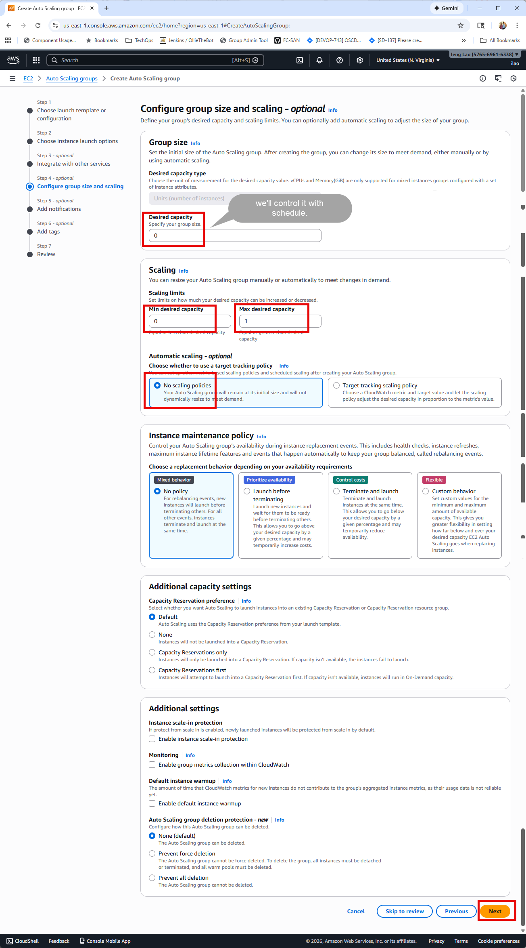

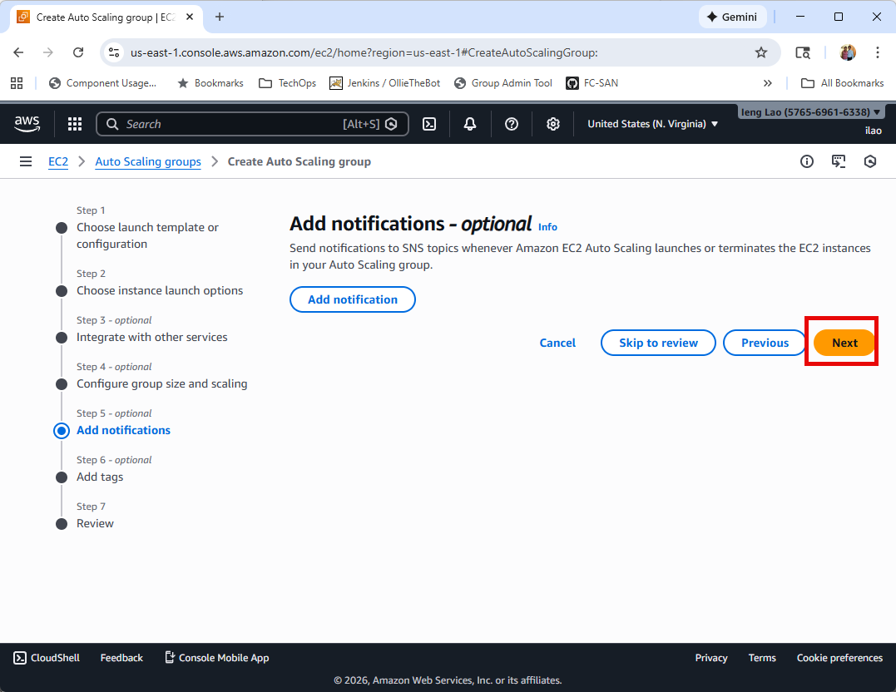

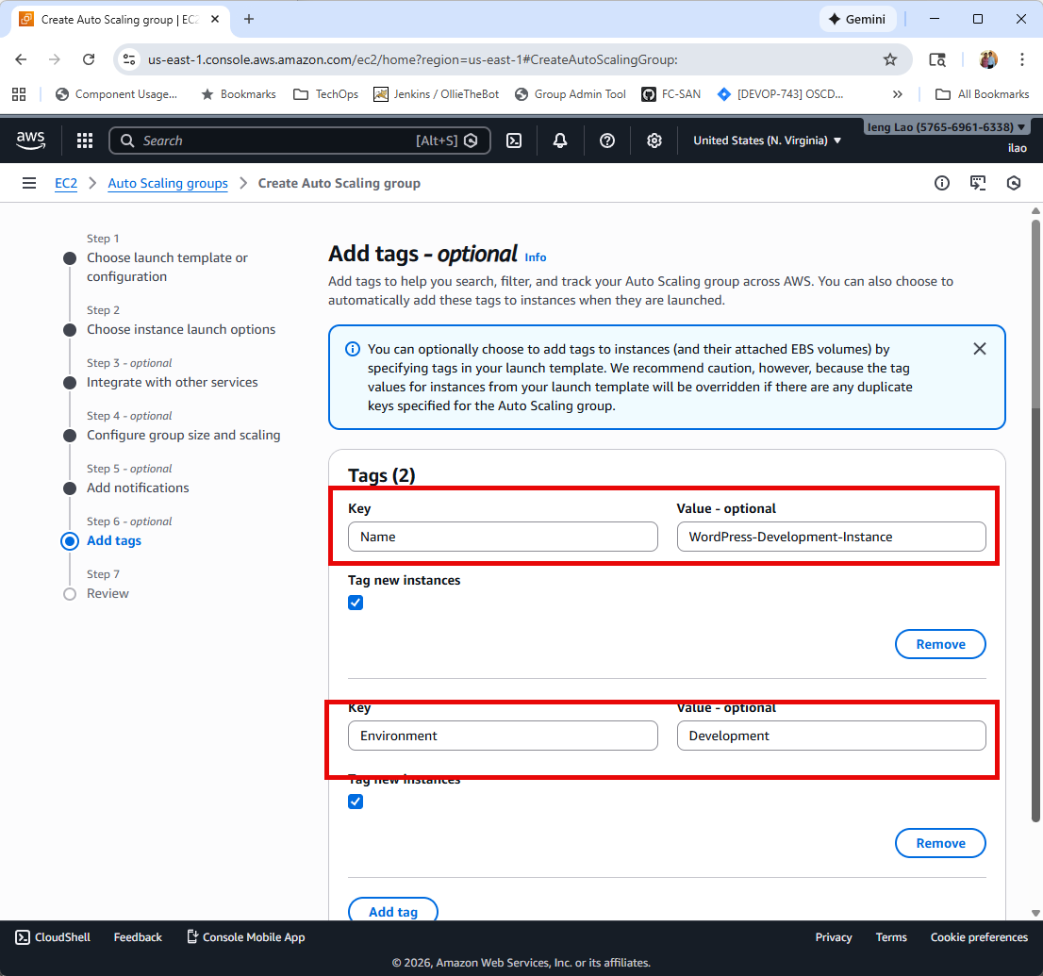

Review all the settings…

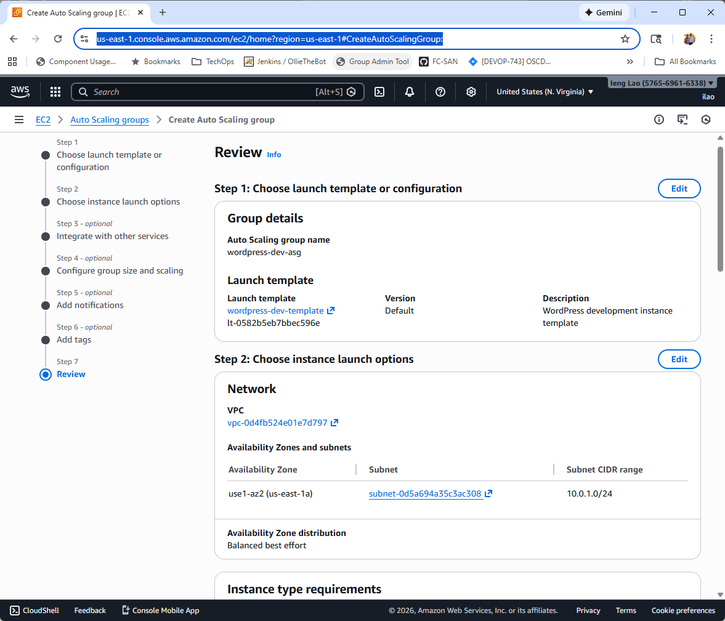

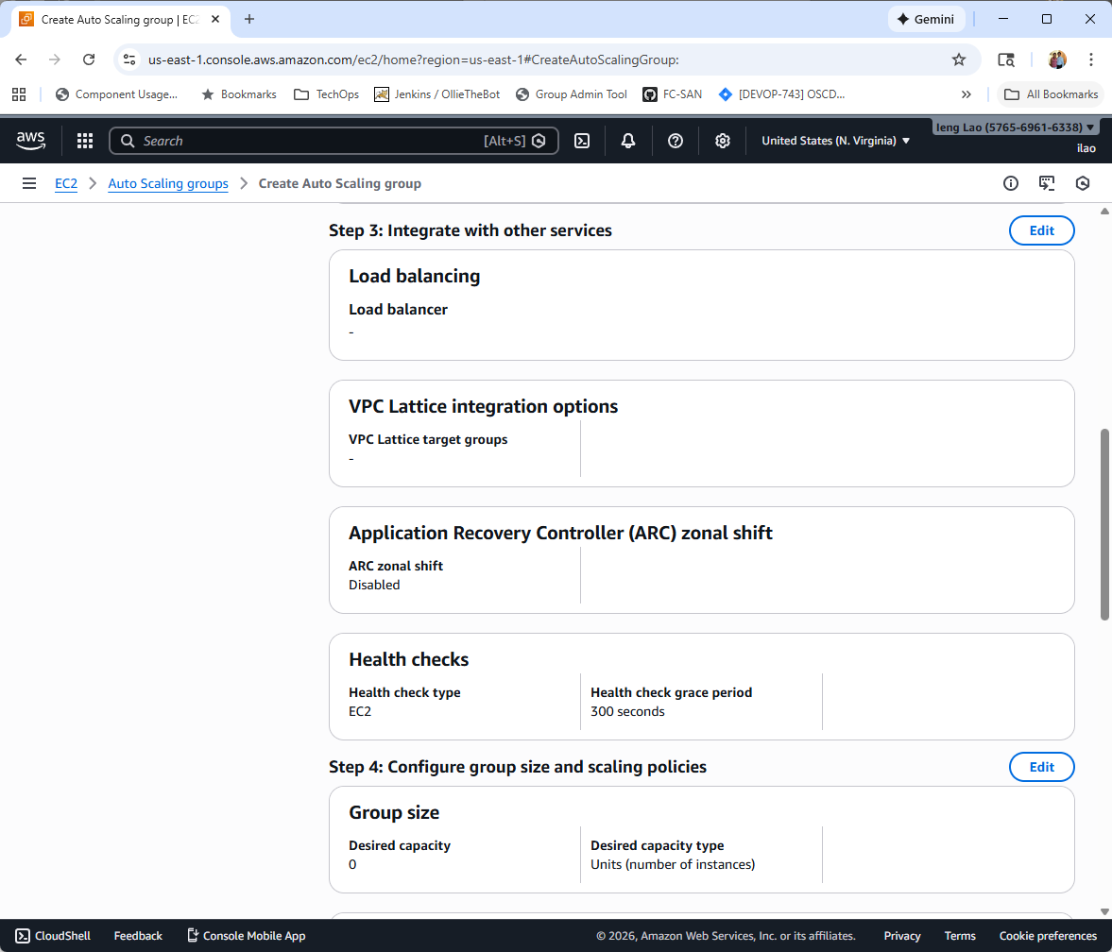

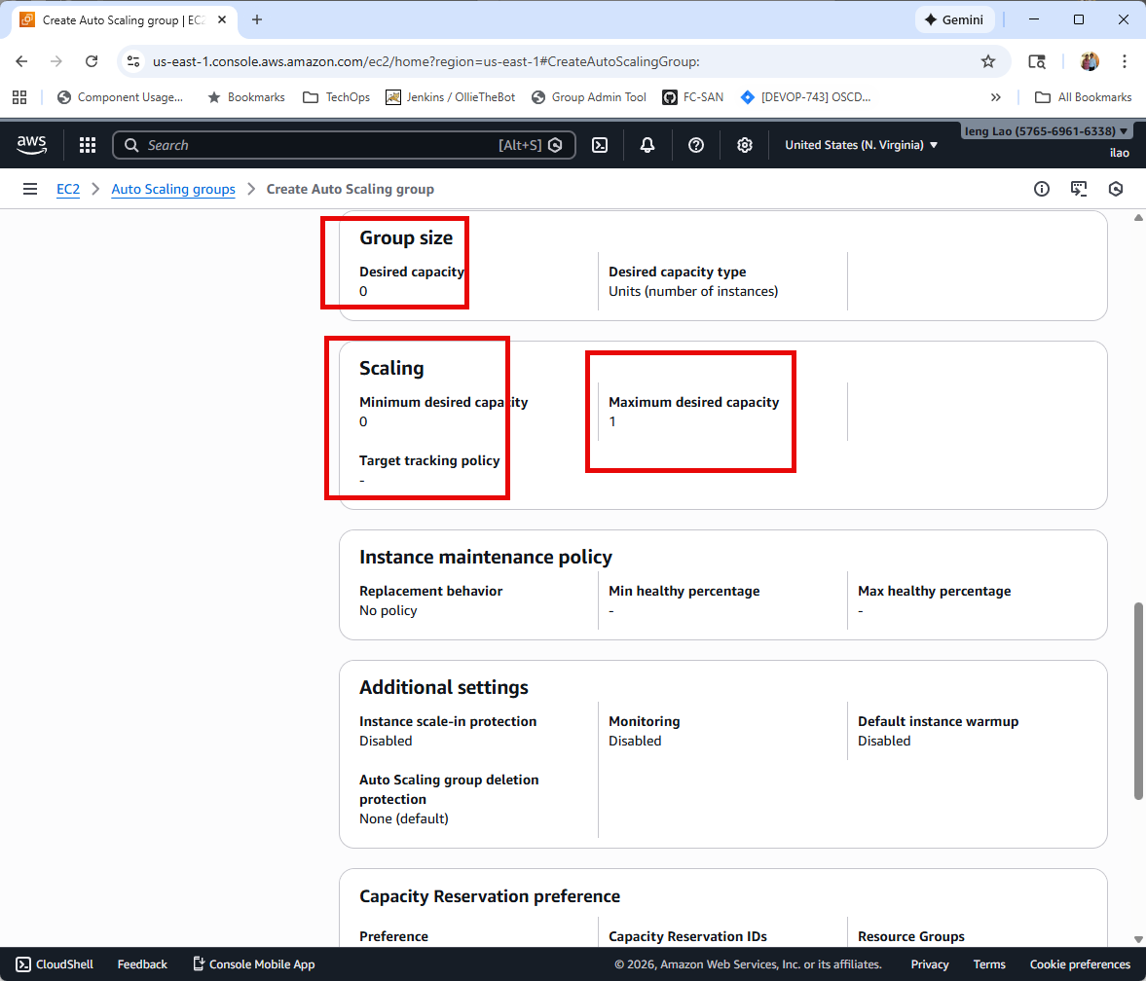

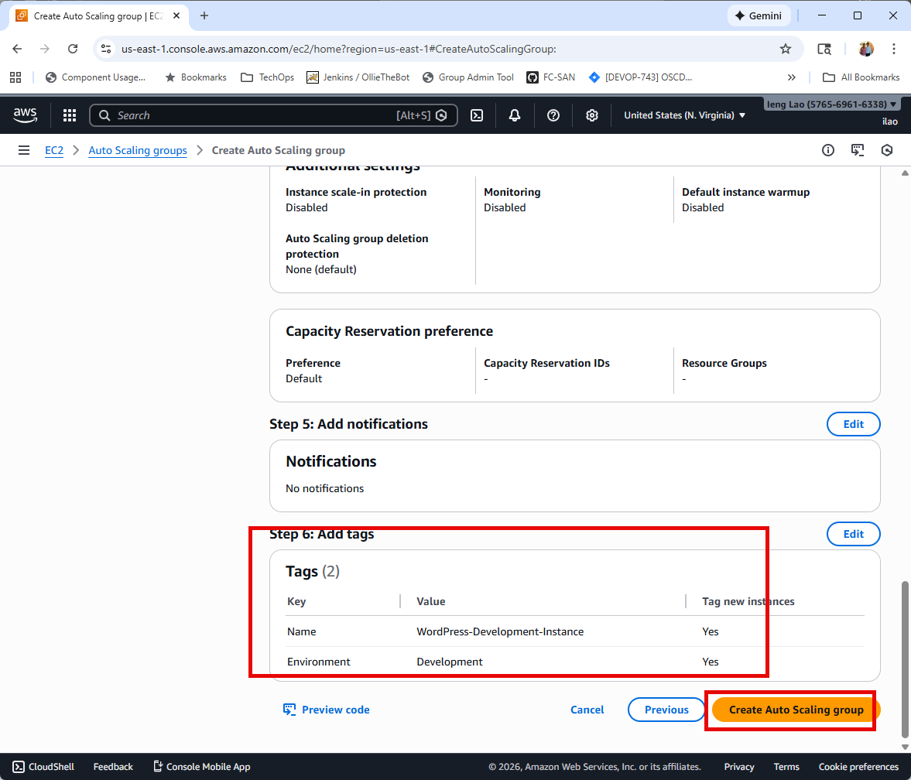

Development Auto Scaling group has been created

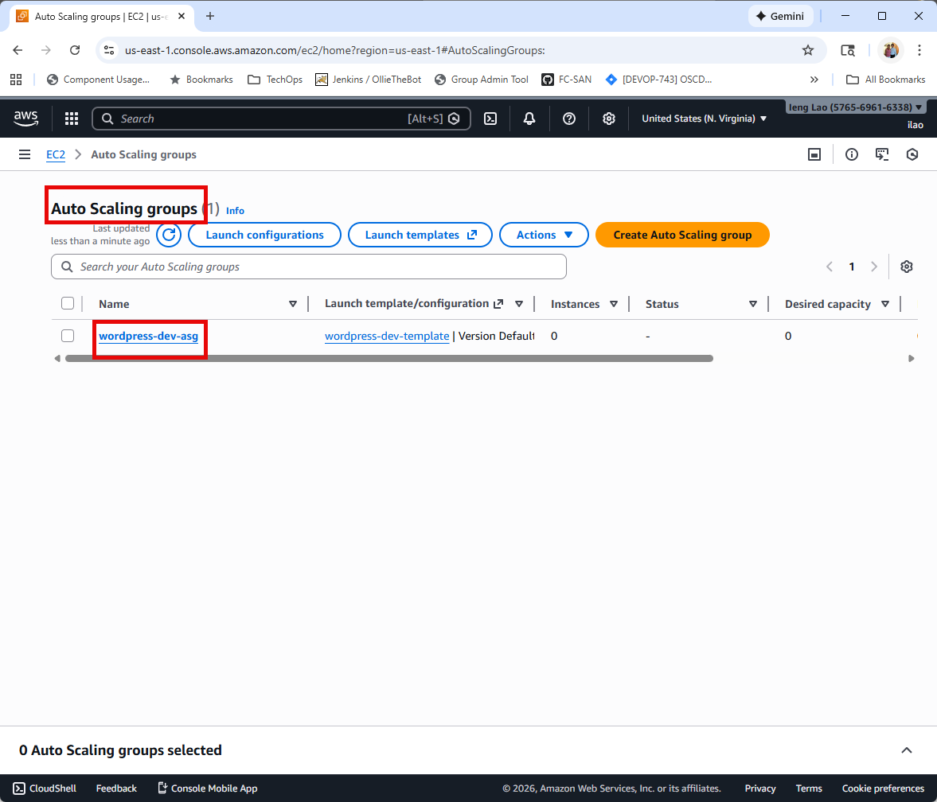

**Task 3.2 : Create Auto Scaling Group - Create Scheduled Actions for 9 AM - 6 PM**

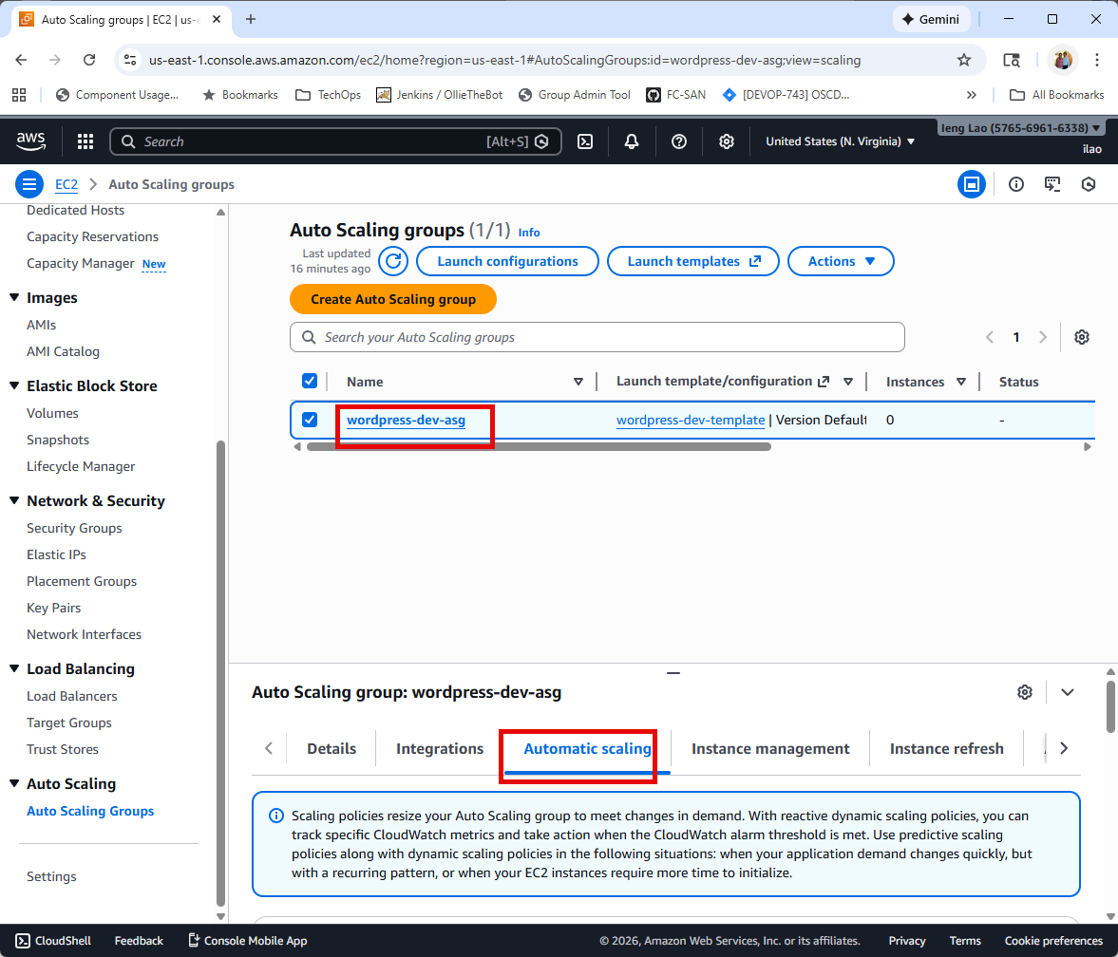

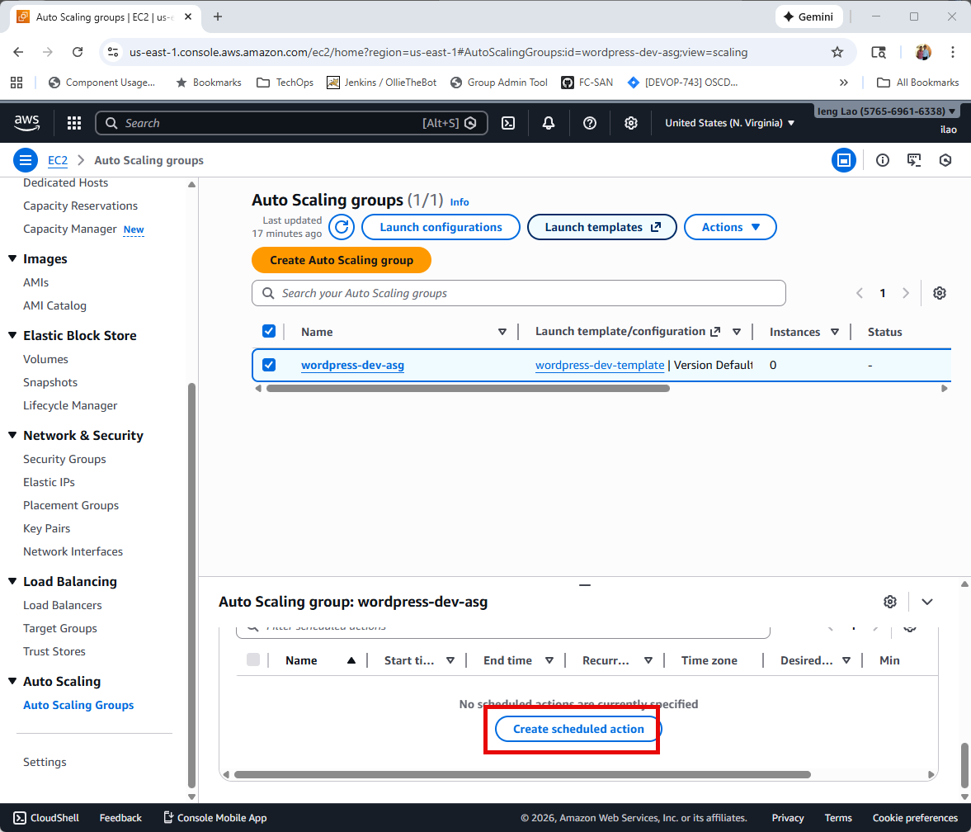

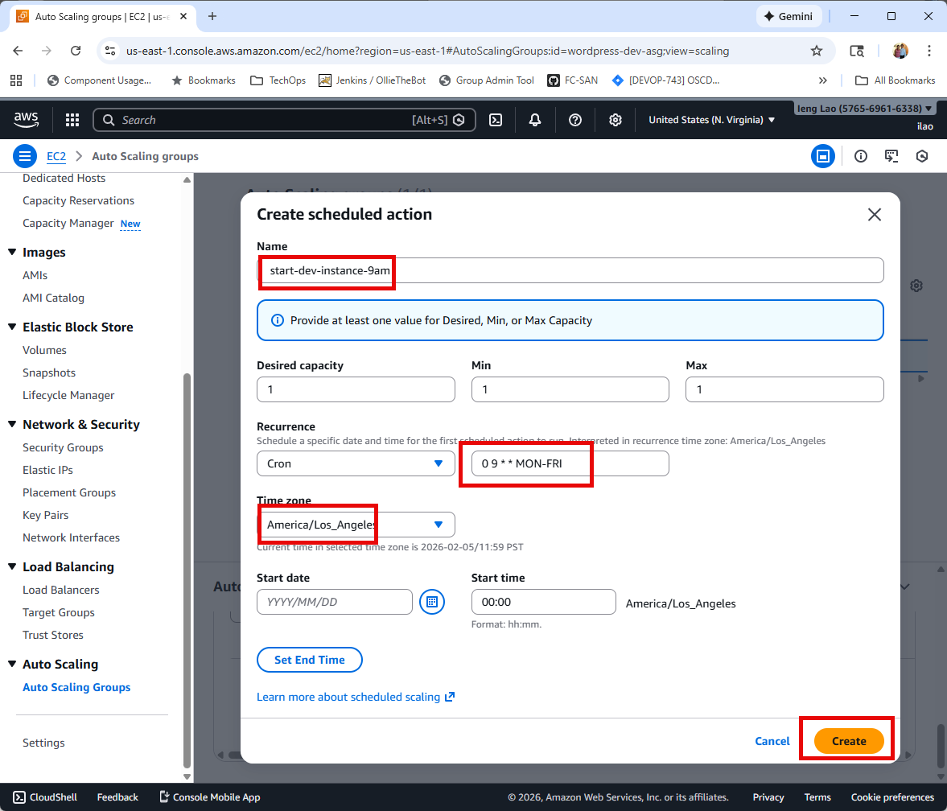

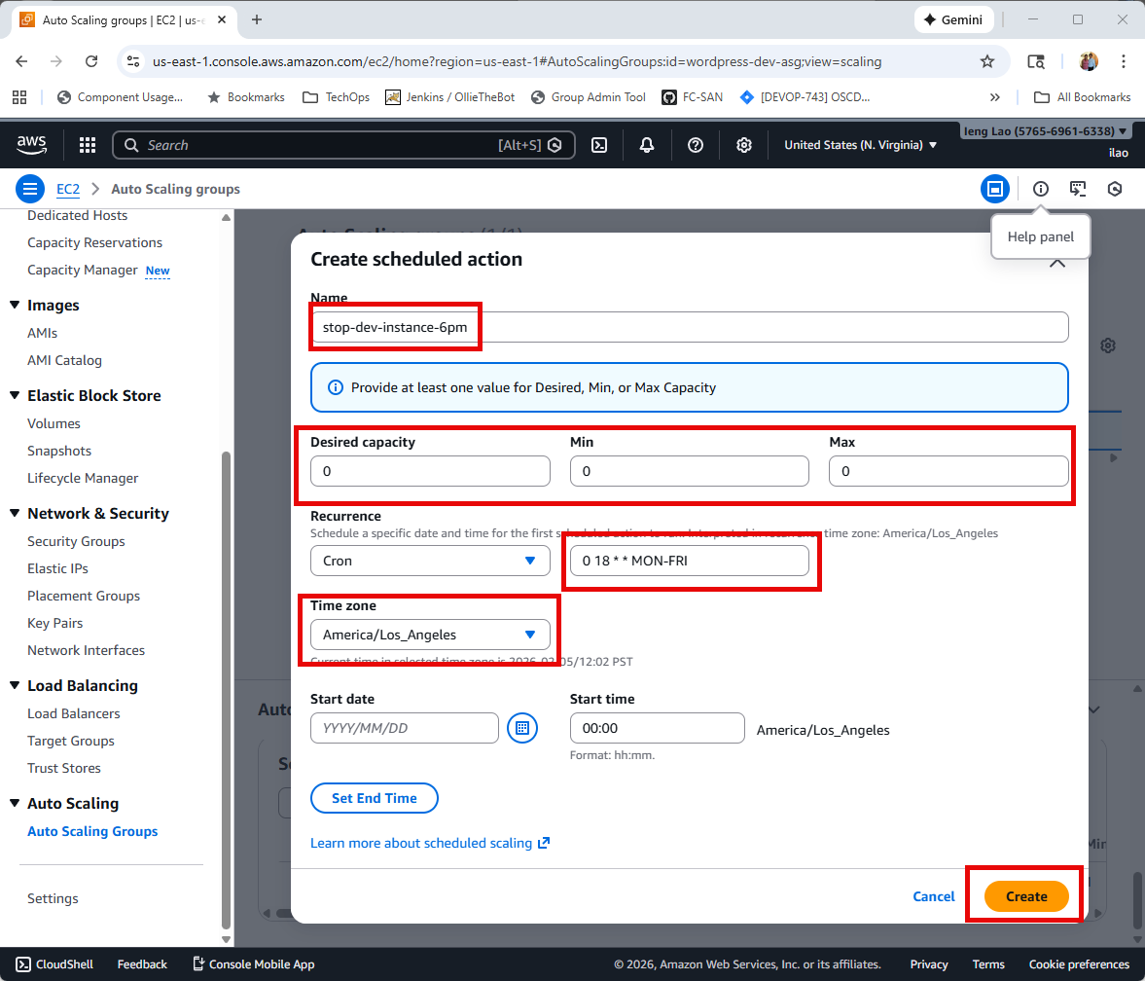

**Task 3.3 : Create Auto Scaling Group – Test Auto Scaling (Manual Test)**

**Change: Desired capacity: 1 & Minimum capacity: 1**

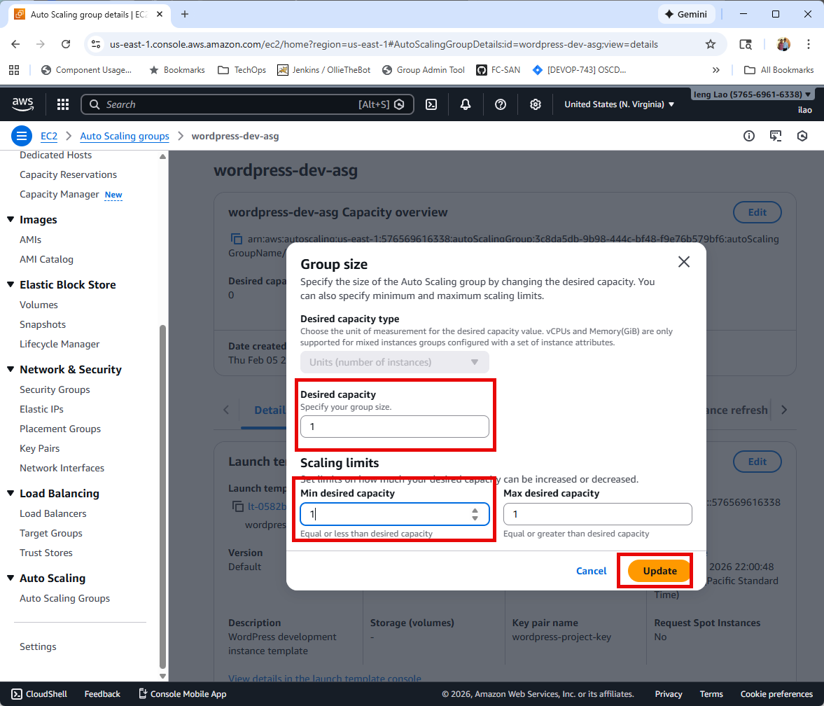

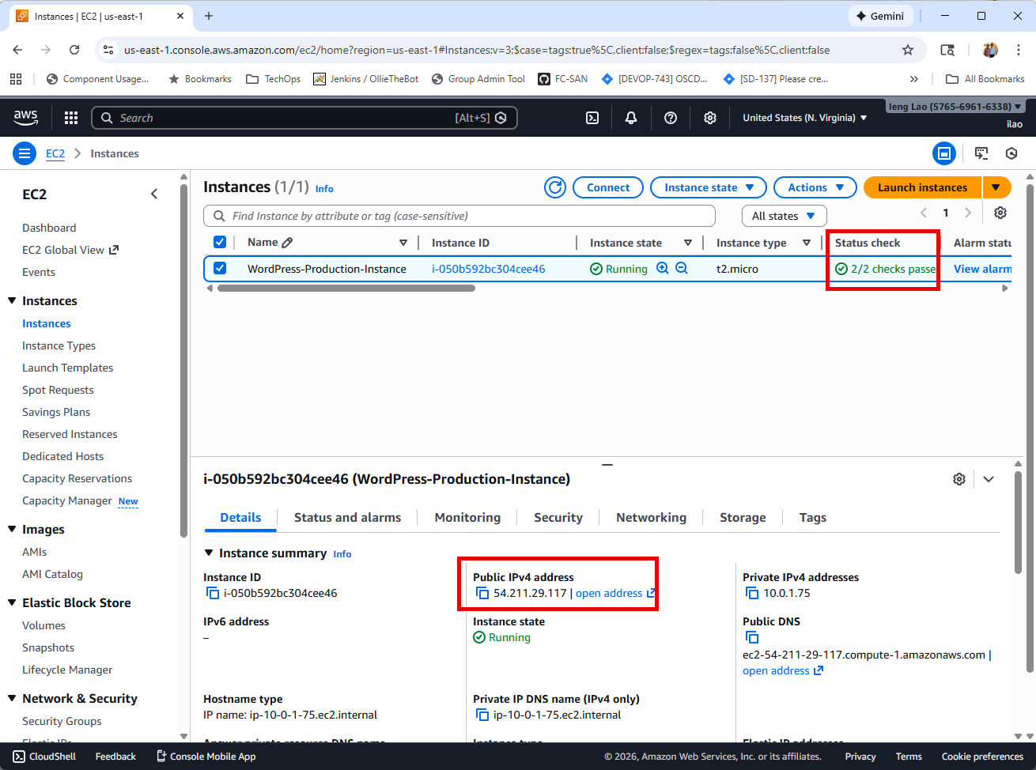

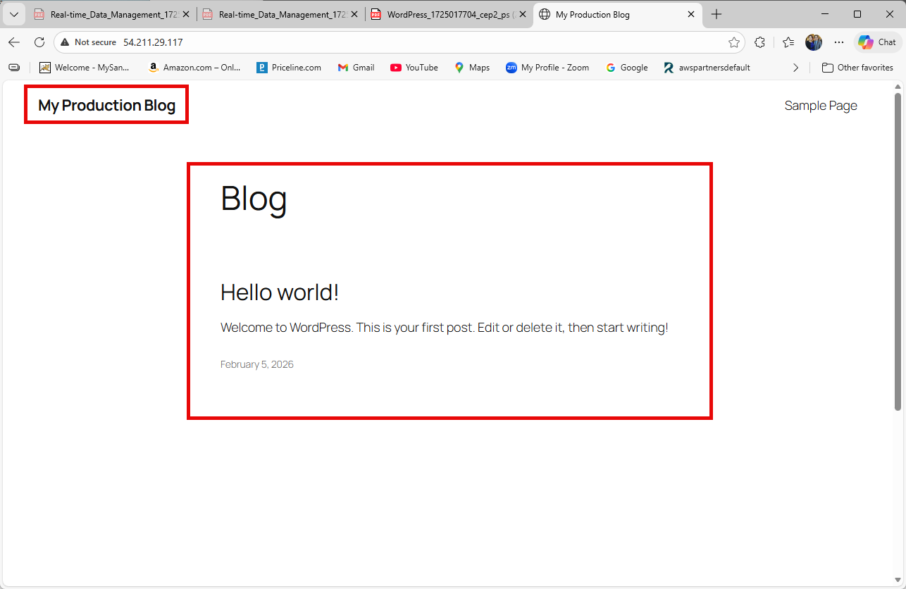

**Task 4 : Verify Automated Shutdown Configuration – schedules enabled**

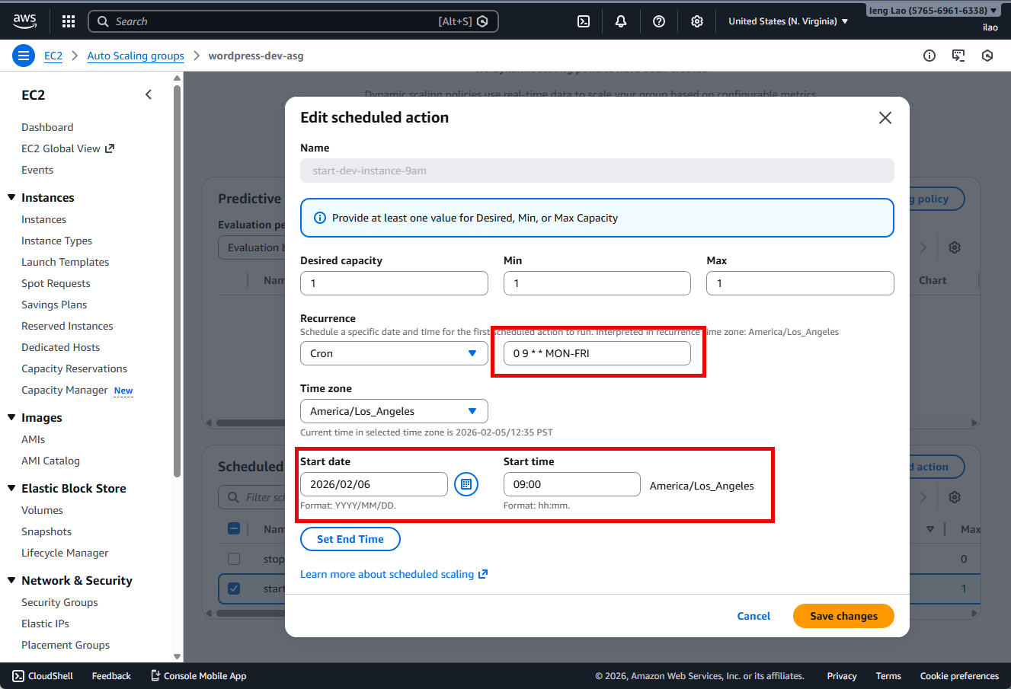

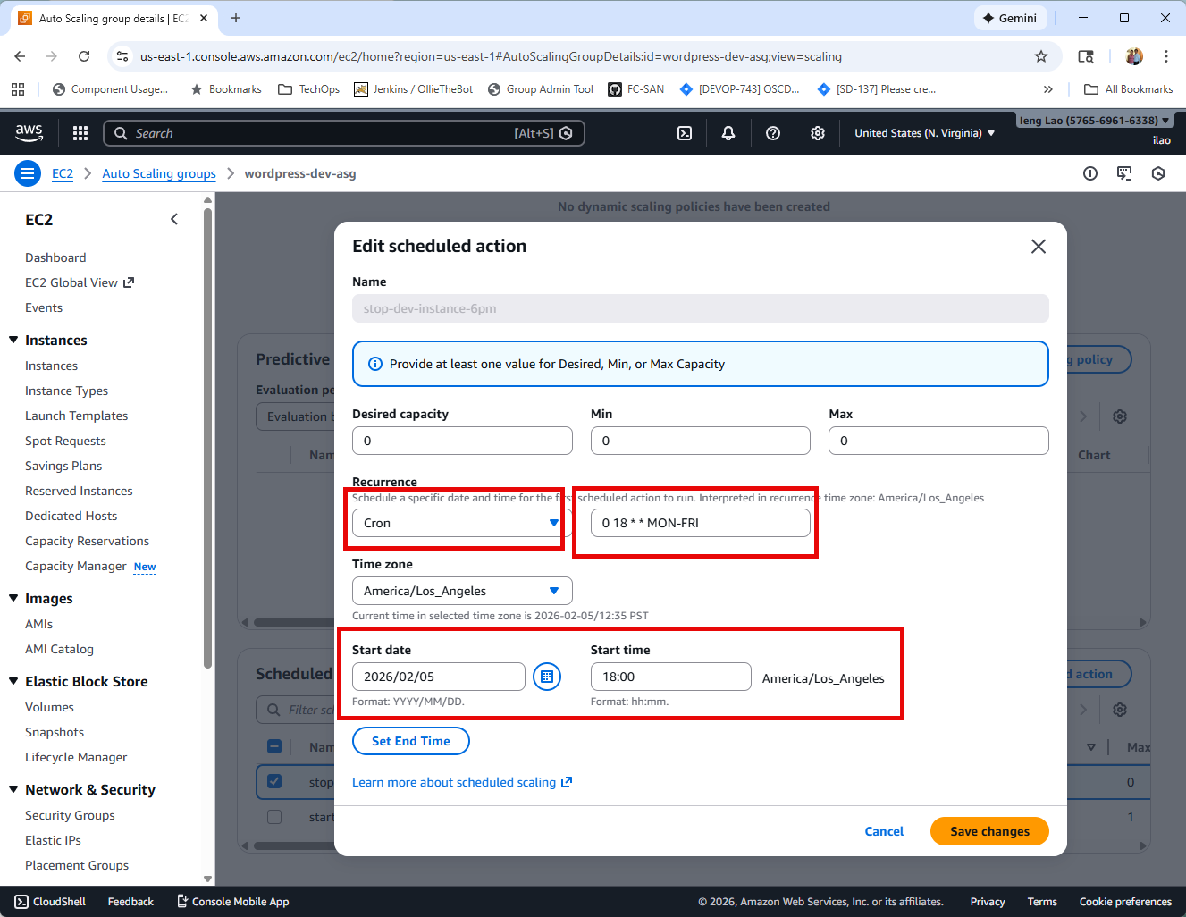

**Task 4.1 : Verify Automated Shutdown Configuration – Monitor and Verification**

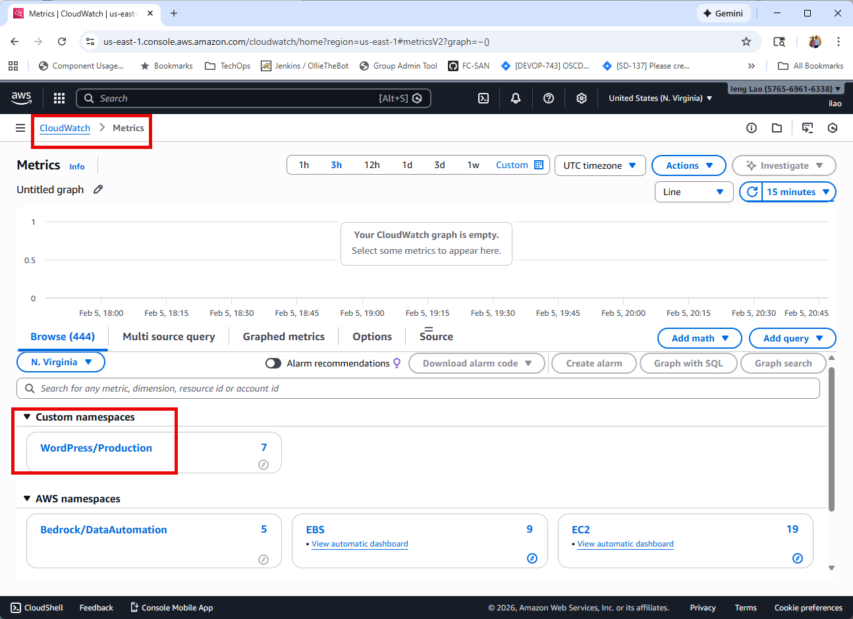

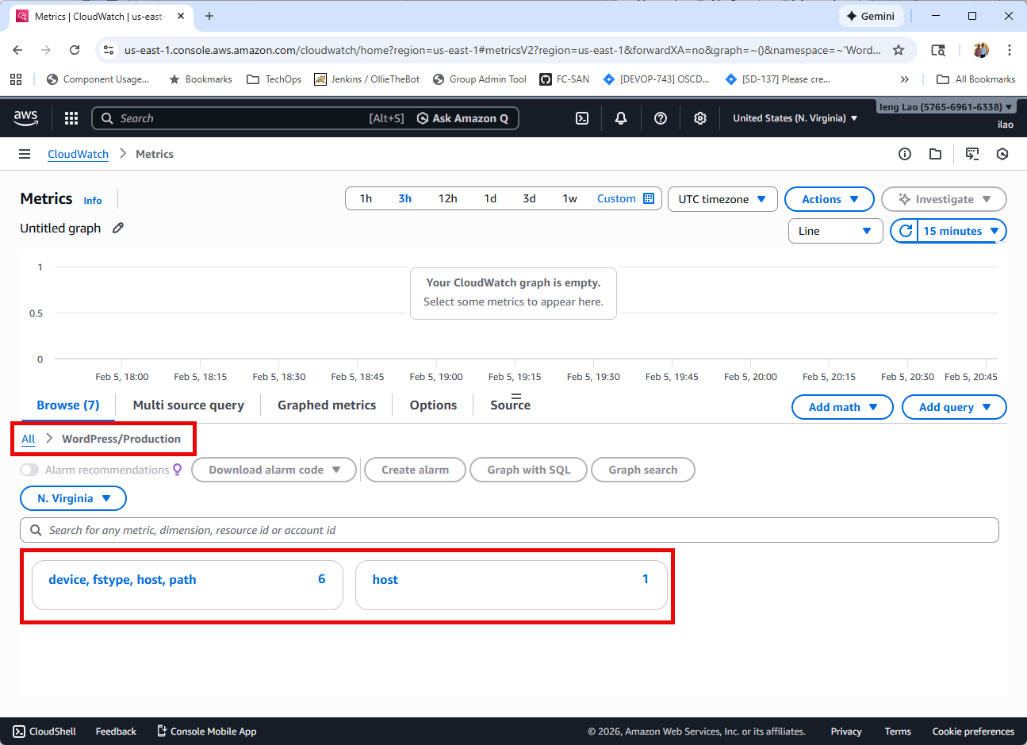

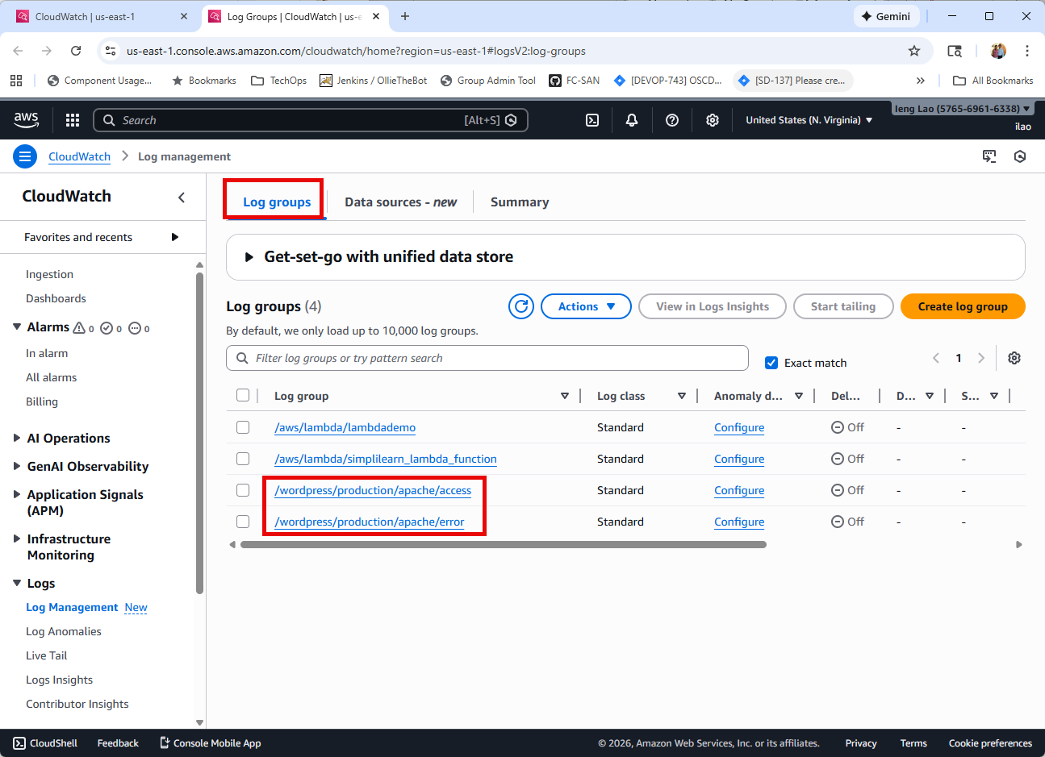

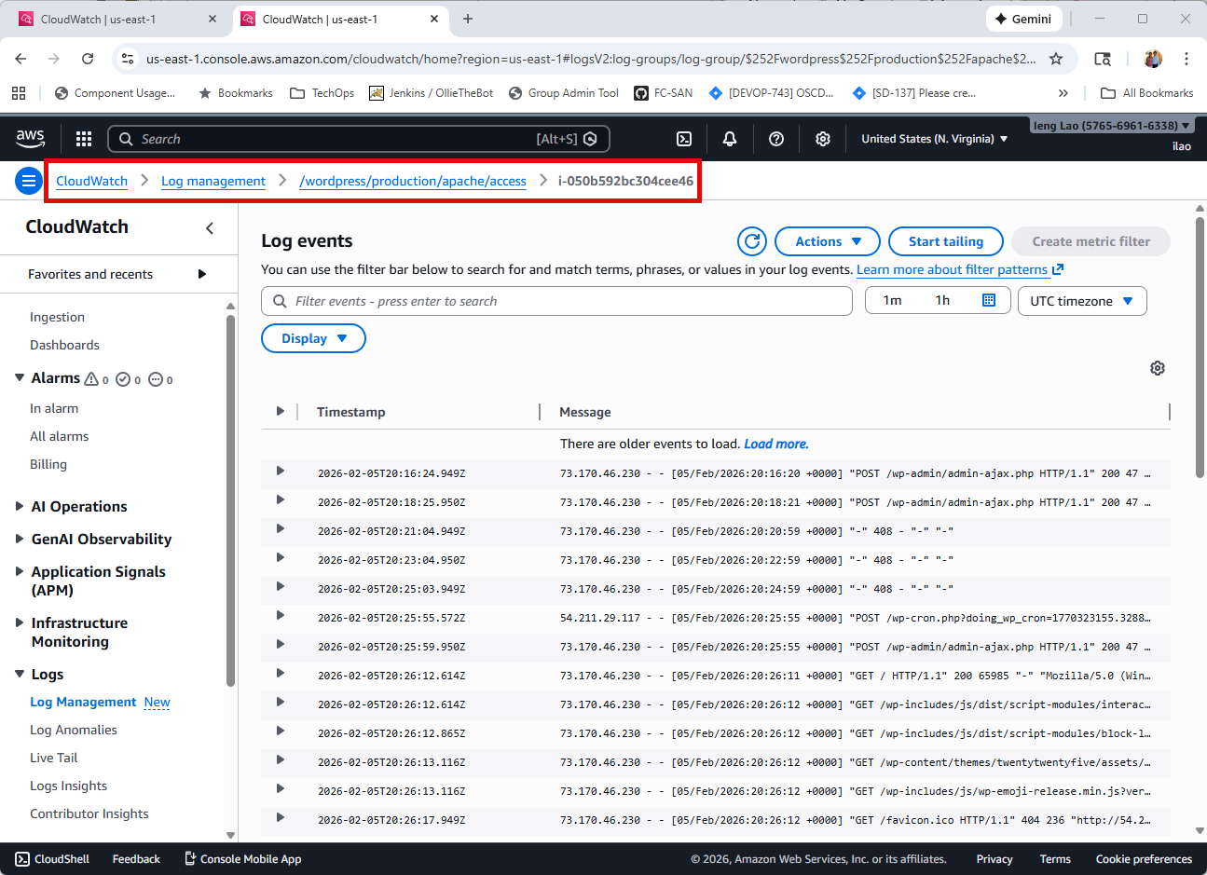

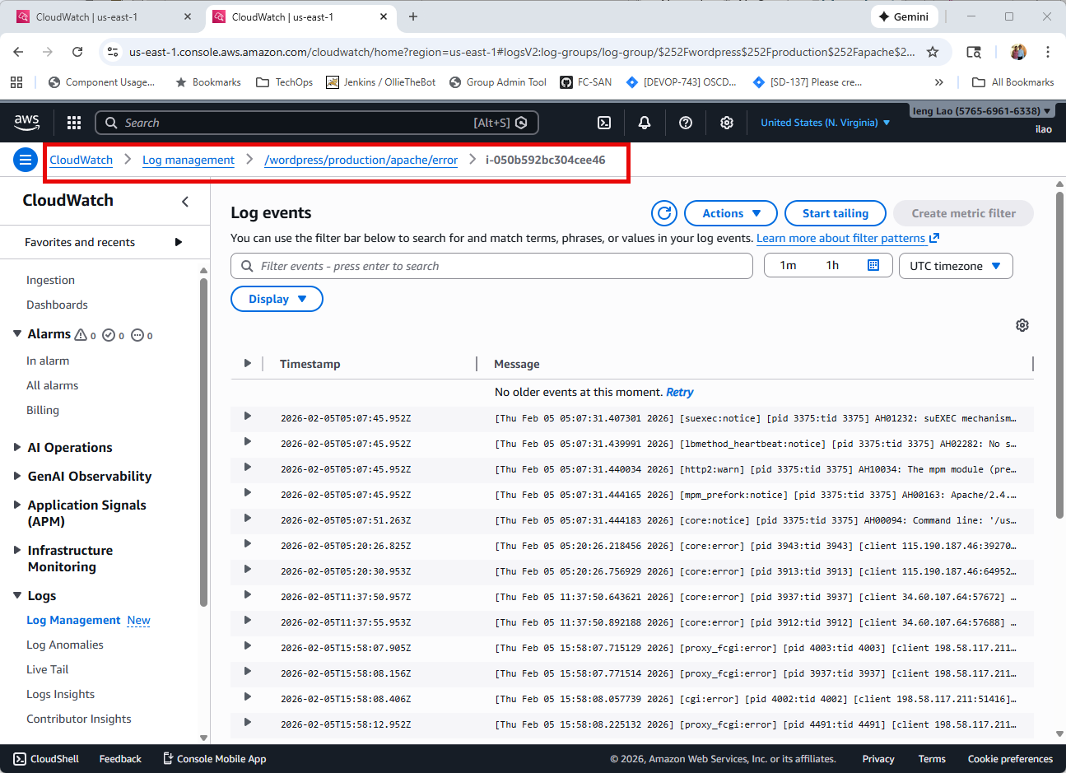

**Task 4.2 : Verify Automated Shutdown Configuration – create dashboard**

1. **In CloudWatch left sidebar, click Dashboards**
2. **Click Create dashboard**
3. **Dashboard name: WordPress-Monitoring**
4. **Click Create dashboard**
5. **Add widget:**
   1. **Select Line widget type**
   2. **Click Next**
   3. **Click Metrics**
   4. **Select WordPress/Production**
   5. **Select CPU, Memory, and Disk metrics**
   6. **Click Create widget**
6. **Click Save dashboard**

**Task 4.1 : Verify Automated Shutdown Configuration – create CloudWatch Alarm**

1. **In CloudWatch, click Alarms → All alarms (left sidebar)**
2. **Click Create alarm**
3. **Click Select metric**
4. **Configure alarm:**
   1. **Statics: Average**
   2. **Period: 5 minutes**
   3. **Threshold: Less than 20 (means CPU usage > 80%)**
   4. **Click Next**
5. **Notification (optional but recommended)**
   1. **Alarm State Trigger: In alarm**
   2. **Select an SNS topic: Create new topic**
   3. **Top name: wordpress-alerts**
   4. **Email: Your email address**
   5. **Click Create topic**
   6. **Click Next**
6. **Name alarm:**
   1. **Alarm name: WordPress-High-CPU**
   2. **Alarm description: Alert when CPU usage exceeds 80%**
   3. **Click Next**
7. **Review and create**
   1. **Click Create alarm**
   2. **Click your email and confirm SNS subscription.**